

**Woven Together: A System Guide for Stephanie’s Creations**

**Prepared for:  
Dr. Andy Bowman  
MIS 4173 – 601  
East Carolina University  
Spring 2025**

**Prepared by:  
Hannah Clark  
Heather Siler  
Lauren Geis**

Table of Contents

I. 2

Executive Summary with Narrative and Conclusions 2

Company Background & Current Environment 2

Problem Analysis (BPA, BPI, BPR) 2

Proposed System Objectives & Constraints 3

Expected Benefits 4

Context Diagram 4

II. 5

Executive Summary with Narrative and Conclusions 5

Use Case Diagram 5

Supplement Specifications (Non-Functional) 6

III. 8

Executive Summary with Narrative and Conclusions 8

Complete Data Flow Diagram Package 9

Hardware and Software Specification 10

Navigation Diagram 10

Entity Relationship Diagram 11

Program Plan – IPO Chart 11

IV. 12

Executive Summary with Narrative and Conclusions 12

Test Plans 13

Training Manual and/or Reference/Procedure Manual 17

Technical Manual 35

V. 63

Executive Summary with Narrative and Conclusions 63

Migration Plan (Business, Technical, People Readiness) 64

All Burndown Charts, All Backlogs, All Meeting Logs 66

# I.

## Executive Summary with Narrative and Conclusions

This section provides an overview of Stephanie’s Creations—a homegrown crochet business that began as a hobby during the COVID-19 pandemic and evolved into a passion-driven small business. Section 1 examines the current manual processes and identifies opportunities for improvement through problem analysis, proposed system objectives, constraints, and expected benefits.  
The new system will introduce inventory tracking, sales management, customer data storage, and e-commerce integration, focusing on ease of use, affordability, and scalability. Expected benefits include increased efficiency, improved organization, and enhanced customer service, enabling Stephanie to expand her business and continue her philanthropic efforts.

Company Background & Current Environment  
Stephanie began crocheting in 2020 as a hobby during the COVID-19 pandemic. After a prolonged battle with Lyme disease, she found comfort in crafting handmade baby blankets, scarves, and hats.

What started as a therapeutic pastime soon became a passion, inspiring her to donate warm clothing to local children in need.Initially, she planned to launch an Etsy shop, but progress was delayed due to hip replacement surgery. Now fully recovered, Stephanie is eager to establish an online business to share her creations with a wider audience while continuing her philanthropic efforts.

Currently, no formal information system is in place. Order management, inventory tracking, and sales are handled manually, with transactions processed through mobile payment apps. Without a centralized system for managing customer data or automating fulfillment logistics, scalability remains a challenge as the business expands.

## Problem Analysis (BPA, BPI, BPR)

Given Stephanie’s current manual workflow, our team recommends a Business Process Improvement (BPI) approach rather than a full Business Process Reengineering (BPR) overhaul. Since she already has an informal system in place and plans to expand to an online platform, refining her existing operations is more practical than a complete restructuring.

While Business Process Automation (BPA) may be considered in the future to streamline tasks such as customer engagement and predictive inventory tracking, our immediate focus is on enhancing system usability and optimizing core processes for efficiency.

## Proposed System Objectives & Constraints

|  |  |
| --- | --- |
| System Objectives | |
| User-Friendly Interface | The system should be intuitive and easy to navigate, requiring minimal technical knowledge. |
| Inventory Management | Enable efficient tracking of available stock, materials, and finished products. |
| Sales Tracking | Provide tools for recording transactions, monitoring sales trends, and generating reports. |
| Customer Management | Maintain customer details, including order history, preferences, and shipping information, to enhance service. |
| E-commerce Integration | Support seamless integration with online marketplaces to streamline product listings and order processing. |
| Cost-Effective Solution | Minimize recurring costs while maintaining essential functionality. |
| Security & Compliance | Ensure secure storage of customer payment details and personal information in compliance with industry standards. |

|  |  |
| --- | --- |
| System Constraints | |
| Budget Limitations | The system must operate within financial constraints, including hosting, payment processing, and potential subscription fees. |
| Accessibility Considerations | Design must accommodate various visual needs, ensuring readability and ease of use. |
| Limited Technical Expertise | The system should require minimal maintenance and technical knowledge. |
| Scalability | While initially designed for small-scale operations, the system should allow for future expansion. |
| Platform Compatibility | The system should integrate seamlessly with potential websites or e-commerce platforms. |

## Expected Benefits

**Improved Efficiency**

Automating sales, inventory tracking, and order fulfillment will significantly reduce the time and effort required for manual data entry and management. By minimizing repetitive tasks, Stephanie can focus more on creating new products and engaging with customers.

**Scalability**

Implementing a structured system will allow the business to grow without overwhelming manual processes. As demand increases, the system will support additional orders, new product listings, and expanded inventory without requiring extensive operational changes.

**Enhanced Organization**

A centralized platform for order tracking, inventory management, and customer interactions will create a more streamlined and structured workflow. This will reduce errors, prevent stock discrepancies, and ensure that Stephanie always has a clear overview of her business operations.

**Better Customer Service**

By automating fulfillment processes and maintaining accurate records of customer orders and preferences, Stephanie can ensure timely and error-free deliveries. Improved tracking capabilities will also help her provide quick responses to customer inquiries, enhancing overall satisfaction and loyalty.

## Context Diagram

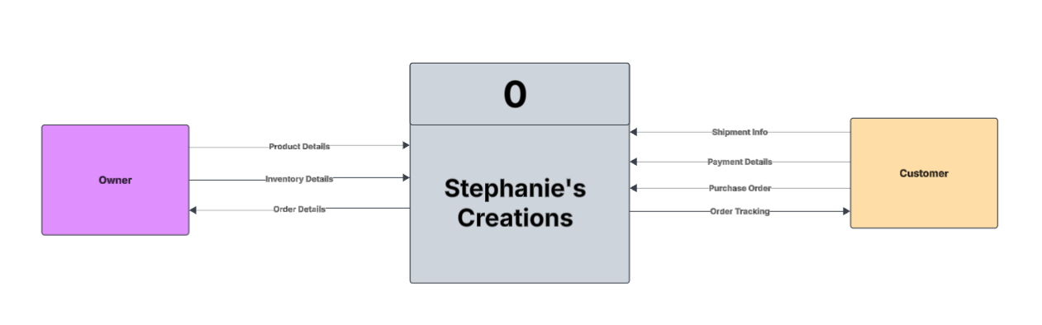

# II.

## Executive Summary with Narrative and Conclusions

In developing Stephanie’s crocheting business website, we have given a lot of attention to making sure that the user’s experience is as smooth and secure as possible. This section describes the system’s non-functional requirements and uses a use case diagram to show how the system interacts.

The use case diagram shows key interactions which include product management, inventory tracking, and payment processing. The non-functional requirements include usability, performance, security, portability, and legal aspects. The system will be user-friendly and easy to navigate. Measures of performance are fast response times and high availability, and security features include data encryption.

## Use Case Diagram

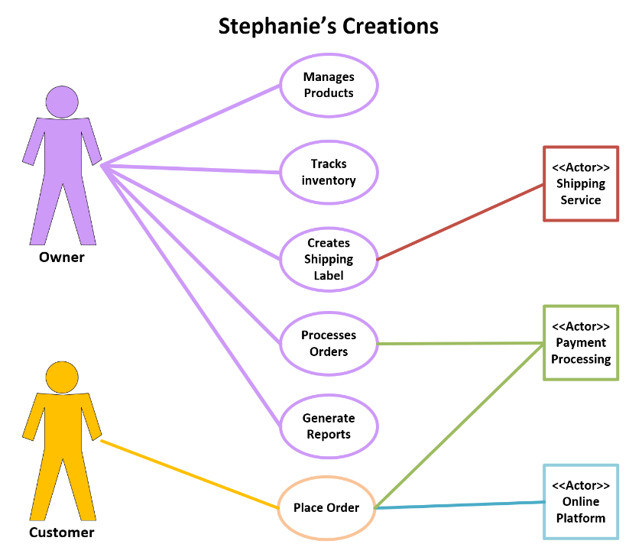

## Supplement Specifications (Non-Functional)

**Operational Specifications**

**1.1 Training and Support:**

**1.1.1 Minimal Training Requirement:** The system shall be designed to minimize end-user training. Stephanie shall be able to perform core functions with no more than 1 hour of initial training.

**1.1.2 Intuitive User Interface:** The user interface shall adhere to established usability guidelines, employing clear labels, consistent navigation, and logical workflows.

**1.1.3 Contextual Help:** Contextual help shall be available for all features, providing on-screen guidance and explanations.

**1.1.4 User Manual and Support Tools:** A comprehensive user manual, FAQ, and video tutorials shall be provided to support Stephanie in using the system.

**1.2 Accessibility:**

**1.2.1 Font and Contrast:** The system shall utilize font sizes and color contrasts that meet WCAG (Web Content Accessibility Guidelines) AA standards.

**1.2.2 Screen Reader Compatibility:** The system shall be compatible with commonly used screen reader software.

**1.2.3 Adjustable Font Sizes:** The system shall allow users to adjust font sizes to accommodate visual needs.

**1.3 System Maintenance:**

**1.3.1 Scheduled Maintenance:** Scheduled maintenance shall be performed during off-peak hours to minimize disruption to Stephanie's business.

**1.3.2 Maintenance Notifications:** Stephanie shall receive advance notification of scheduled maintenance.

**Performance Specifications**

**2.1 Response Time:**

**2.1.1 Key Operations:** Key operations (add inventory, process sale, generate report) shall have a response time of ≤ 2 seconds under normal load conditions.

**2.1.2 Page Load Time:** Web page load times shall be ≤ 3 seconds.

**2.2 Scalability:**

**2.2.1 Transaction Volume:** The system shall be able to handle a 50% increase in transaction volume within the first year without exceeding the 2-second response time requirement.

**2.2.2 Inventory and Customer Records:** The system shall accommodate a 50% increase in inventory items and customer records within the first year without significant performance degradation (defined as a response time increase of > 0.5 seconds).

**2.3 Availability:**

**2.3.1 Uptime:** The system shall maintain 99.5% uptime, excluding scheduled maintenance windows.

**2.3.2 Monitoring:** System availability shall be continuously monitored, and alerts shall be generated for any downtime.

**2.4 Data Capacity:**

**2.4.1 Storage:** The system shall have storage capacity to accommodate three years of transaction data, customer information, and inventory records.

**2.4.2 Database Performance:** Database queries shall be optimized to maintain performance as data volume increases.

**Security Specifications**

**3.1 Data Encryption:**

**3.1.1 Encryption in Transit:** All sensitive data transmitted over the network shall be encrypted.

**3.1.2 Encryption at Rest:** Customer payment information and personal details shall be encrypted at rest.

**3.1.3 Key Management:** Encryption keys shall be securely managed and stored.

**3.2 Access Control:**

**3.2.1 Role-Based Access Control (RBAC):** The system shall implement RBAC, with predefined roles and permissions.

**3.2.2 Authentication:** Users shall be authenticated using strong passwords and/or multi-factor authentication (MFA).

**3.2.3 Authorization:** Stephanie shall have full administrative privileges. Future roles and permissions shall be configurable.

**3.3 Data Backup and Recovery:**

**3.3.1 Automated Backups:** Automated backups shall be performed daily and stored offsite.

**3.3.2 Recovery Time Objective (RTO):** The system shall be recoverable within 24 hours.

**Cultural/Political Specifications**

**4.1 Data Privacy Compliance:**

**4.1.1 Compliance with Relevant Laws, (e.g., GDPR, CCPA):** The system shall comply with all applicable data privacy laws and regulations.

**4.1.2 Privacy Policy:** A clear and concise privacy policy shall be provided to users.

**4.1.3 Data Subject Rights:** The system shall support data subject rights, including the right to access, rectify, and delete personal data.

**4.2 E-commerce Integration:**

**4.2.1 API Integration:** The system shall utilize secure and well-documented APIs for integration with chosen e-commerce platforms.

**4.2.2 Data Synchronization:** Data synchronization between the system and e-commerce platforms shall be reliable and efficient.

**4.3.3 Business continuity:** The system will be designed to allow for easy transition to new platforms, or e-commerce sites, should the need arise.

# III.

## Executive Summary with Narrative and Conclusions

Sprint 3 focused on solidifying Stephanie's crocheting business website's foundational analysis and design elements. We transitioned from high-level user interactions (as outlined in Sprint 2's use case diagrams) to detailed data flow and modeling. This sprint’s work establishes a clear understanding of how data moves through the system and how it will be structured in the database.

The completed Data Flow Diagram (DFD) package provides a visual representation of data movement, from user input to database storage and output. This package ensures that all stakeholders have a shared understanding of the system's processes. We also developed an initial Entity Relationship Diagram (ERD) to define the data entities and their relationships, laying the groundwork for database design.

Furthermore, we created detailed Input-Process-Output (IPO) charts for each program, outlining the logic and I/Os, which will assist in future developments. Hardware and software specifications were defined to ensure the system is built on a robust and scalable platform. A navigation diagram was constructed to visualize the user interface flow, prioritizing a user-friendly experience.

Sprint 3 has successfully transitioned the project from conceptual user interactions to detailed data flow and data modeling. The DFD package, ERD, and IPO charts provides a solid foundation for the development phase, minimizing the risk of misunderstandings and rework. The hardware and software specifications ensure the system will be built on a suitable platform.

**Key Benefits Realized:**

* **Clarity and Shared Understanding:** The DFD package and ERD have provided a clear and shared understanding of the system's data flow and structure, reducing the risk of misinterpretations.
* **Improved Development Efficiency:** The detailed IPO charts and hardware/software specifications will streamline the development process and reduce potential errors.
* **Enhanced User Experience:** The navigation diagram prioritizes a user-friendly interface, contributing to a positive user experience.
* **Reduced Future Maintenance:** Well-documented systems are easier to maintain.

This sprint has laid a critical foundation for the development of Stephanie’s crocheting business website, ensuring a robust, efficient, and user-friendly system. We are now well-positioned to move into the development phase with confidence.

## Complete Data Flow Diagram Package

**Context Diagram**

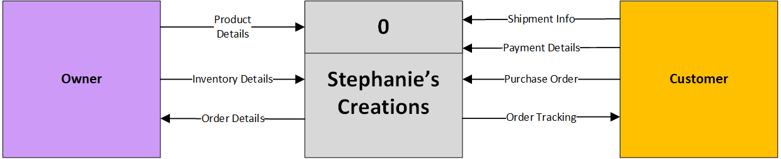

**Level 0 Diagram**

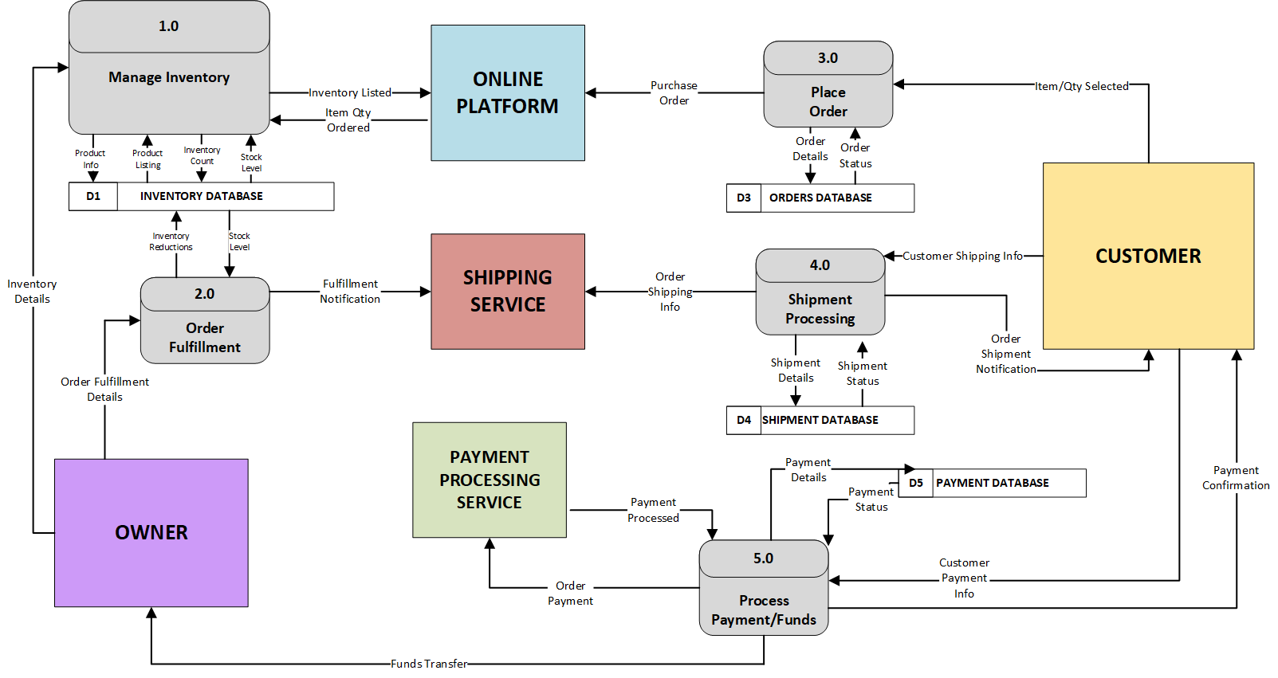

**Level 1 Diagram – Process 1.0**

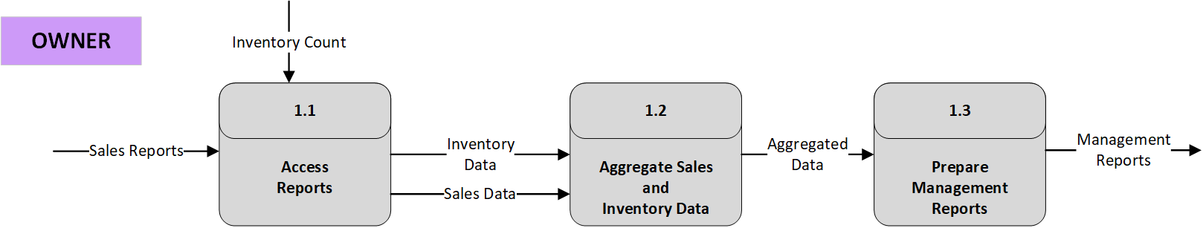

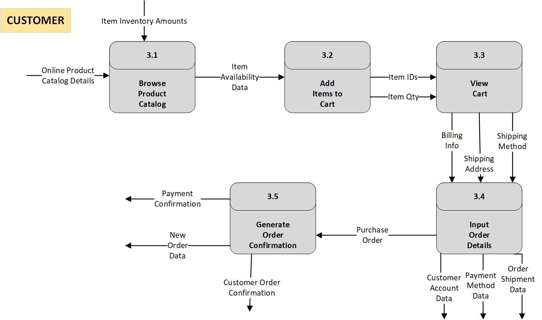**Level 1 Diagram-Process 3.0**

## Hardware and Software Specification

To ensure our system is accessible and user-friendly, we have designed it with minimal hardware and software requirements. This approach is driven by our commitment to client and end-user needs, prioritizing ease of use and broad compatibility. By keeping the requirements simple, we enable a wider range of users to access our system without the need for specialized equipment, thus enhancing user engagement and satisfaction.

**Hardware Requirements**

* Any laptop or mobile device that can connect to the internet
* Router to connect to the internet

**Software Requirements**

* Any laptop or mobile device that can connect to the internet

This streamlined setup ensures that our system is functional and efficient across various devices and internet connections, facilitating seamless integration into users' daily operations.

## Navigation Diagram

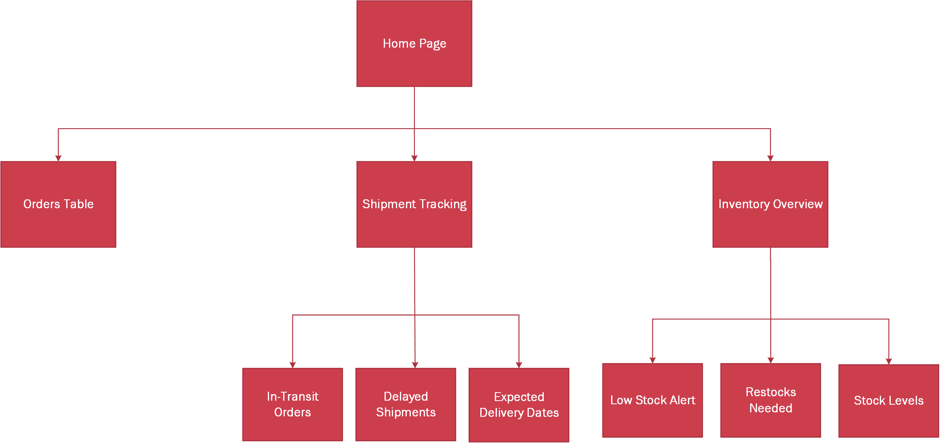

## Entity Relationship Diagram

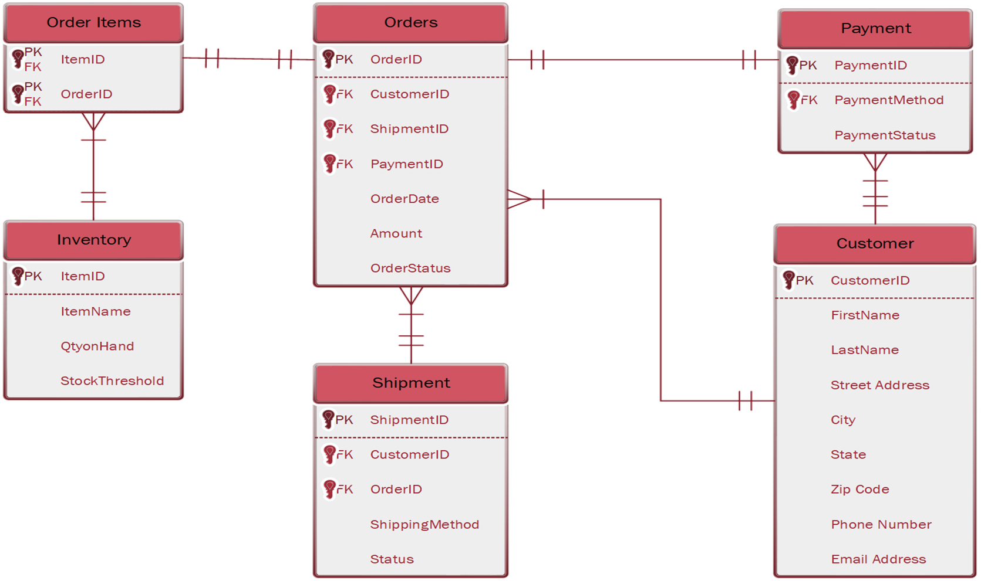

## Program Plan – IPO Chart

|  |  |  |  |
| --- | --- | --- | --- |
| Program | Inputs | Outputs | Processing Steps |
| Home Page | * Orders Table * Shipment Tracking * Inventory Overview | * Order Status * Shipment Tracking * Inventory Summary | 1. Fetch data from Orders, Shipments, and Inventory 2. Aggregate and format data 3. Display results |
| Orders Table | * Customer Name * Item * Payment | * Order History * Order Status | 1. Validate inputs (name, item, payment) 2. Generate unique Order ID 3. Store order in database 4. Update order status |
| Shipment Tracking | * New Orders * Older Orders | * In-transit Orders * Delayed Shipments * Expected Delivery Dates | 1. Retrieve shipping details from the database 2. Calculate estimated delivery 3. Update shipment status |
| Inventory Overview | * Product Stock Level * Supplier Data | * Low Stock Alerts * Restock Notifications * Updated Stock Levels | 1. Check stock levels 2. Generate restock alerts if needed 3. Update inventory database |

# IV.

## Executive Summary with Narrative and Conclusions

Sprint 4 marked a significant step in the project's progression, focusing on user adoption and practical application. A key deliverable was the development and execution of a targeted 10-minute training session for a critical system actor. This training was designed to empower the actor to perform job-specific tasks within the system, emphasizing practical application over a comprehensive system overview. We concentrated on the relevant use cases, ensuring the actor felt confident and capable of utilizing the system effectively in their daily workflow.

Beyond training, we continued to refine our project management processes. We updated the System Product Backlog to reflect the evolving project landscape and created the Sprint 4 Backlog to guide our team's efforts. The Sprint 4 Burn Down Chart and PSPI (Project Sprint Performance Indicator) were also completed, providing valuable insights into our team's efficiency and progress. Additionally, we included any relevant project updates to maintain transparency and ensure all stakeholders were informed of our progress.

**Key Benefits Realized:**

* **Enhanced User Adoption:** Job-specific training led to faster user proficiency and increased confidence.
* **Improved User Buy-In:** Highlighting the system's benefits and focusing on practical application fostered positive user engagement.
* **Effective Project Management:** Updated backlogs and performance indicators ensured project transparency and progress tracking.
* **Practical Application Focus:** Concentrating on use cases, and the actor's job, rather than system overview, made the training more effective.
* **Clear and Concise Communication:** The initial explanation of the systems benefits, was clear and concise.

This sprint has laid a solid foundation for future user training and has demonstrated the system's practical value in a real-world context. We are well-positioned to continue our progress, ensuring the system's successful implementation and adoption.

## Test Plans

This section presents our Test Plan, which ensures that the system meets all requirements. Below, you'll find a Test Plan Template to guide the documentation of test cases, followed by a completed test example. This example demonstrates how to use the template effectively. Adjust test cases as necessary to cover all essential functionalities.

**Program ID: Crochet Manager Version Number: 1.0  
Date Designed: 3/24/2025 Date Conducted: //2025  
  
Actor 1: Stephanie - Business Owner/Administrator Test ID:** Click or tap here to enter text. **Tester:** Click or tap here to enter text. **Results: -   
Requirement Addressed: Update Inventory Items  
Objective:** Easily add, edit and delete inventory items based on stock level.

|  |  |  |  |
| --- | --- | --- | --- |
| Interface ID | Data Field | Value Entered | Result |
| Login | Email | Click or tap here to enter text. |  |
| Home | Password | Click or tap here to enter text. |  |
| Inventory | Product Name | Click or tap here to enter text. |  |
| Inventory | SKU | Click or tap here to enter text. |  |
| Inventory | Quantity | Click or tap here to enter text. |  |
| Inventory | Color(s) | Click or tap here to enter text. |  |

**Script:**

1. **Log in to the System:**

* Open the system using the provided credentials.
* Navigate to the dashboard.

1. **Add New Inventory Item:**

* Go to the 'Inventory Management' section.
* Click on 'Add New Item'.
* Enter the following details for a new inventory item:
  + Name: ""Scarf" "
  + SKU: "SKU1001"
  + Quantity: "2"
  + Color(s): “Black”
* Click “Add Item” and confirm that the item appears in the inventory list with the correct details.

1. **Update an Existing Item:**

* Select an existing item from the inventory list, named "Scarf", SKU # “SKU1001”.
* Click 'Edit'.
* Change the quantity from 2 to 80.
* Save changes and verify that the updated details are correctly displayed in the inventory list.

1. **Remove an Item:**

* Choose an item labeled "Scarf", SKU # “SKU1001”. from the inventory.
* Click on 'Delete' and confirm the deletion.
* Ensure the item is no longer listed in the inventory.

1. **Check for Errors:**

* Attempt to add a new item with incomplete details (e.g., missing price).
* Ensure the system prompts for the missing information before allowing the item to be added.

**Expected Results/Notes:**Stephanie should be able to perform all administrative tasks without technical difficulties, reflecting changes immediately in the system.

**Actual Results/Notes:**Click or tap here to enter text.

**Completed Test Plan:**

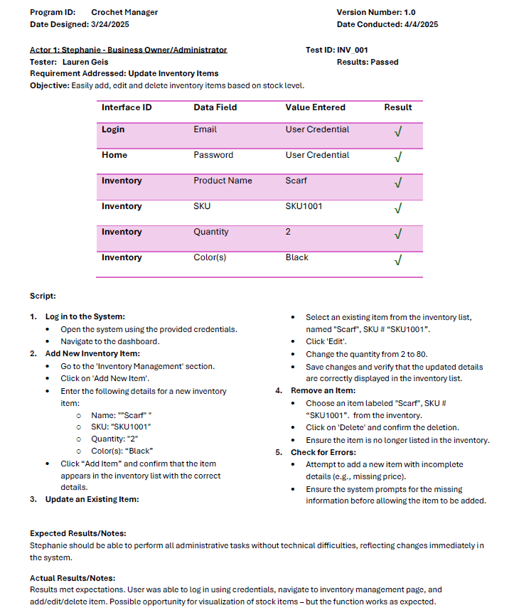

## Training Manual and/or Reference/Procedure Manual



Welcome to our comprehensive training manual designed to guide you through the key functionalities and operations of our system. Whether you're a new user or looking to refresh your skills, this manual provides step-by-step instructions and practical examples to ensure you can navigate and utilize our system with confidence.

Dive into each section prepared to enhance your understanding and skills, and don't hesitate to refer to this manual as a reliable resource in your daily operations.

Access Stephanie’s Creations using this link: [**Welcome to Stephanie’s Creations!**](https://crochet-manager-dev.web.app/)

System Login

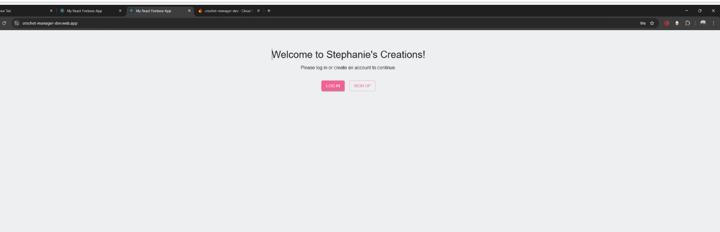

Figure 1.0

Option 1 - User Login

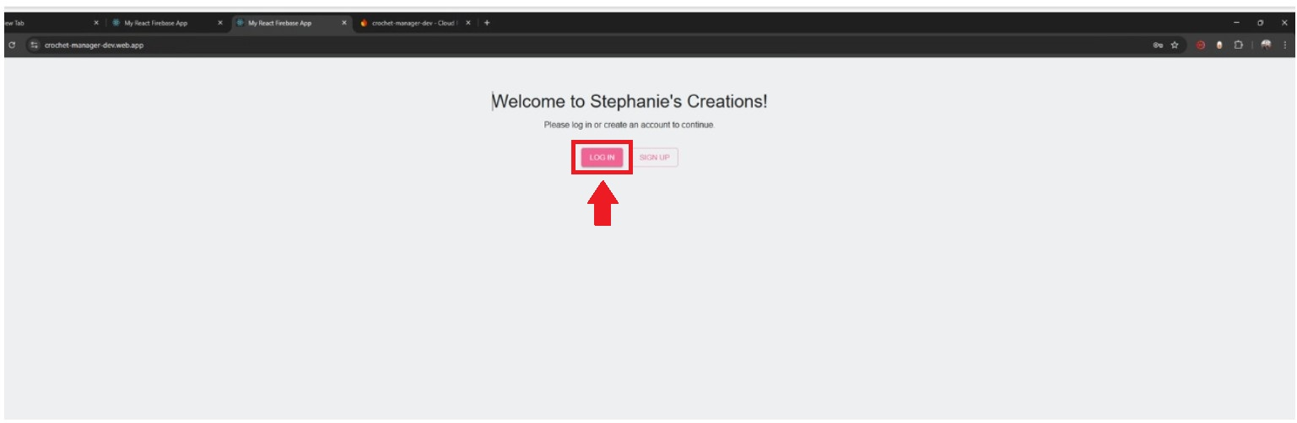

Figure 1.1

1. Open the Login Screen:

Look for the "LOGIN" button. It's a dark pink button, usually located on the main screen.

Click the **dark pink LOGIN button** with your mouse.

2. Enter Your Username:

A new screen will appear with two boxes.

In the top box, labeled "Username," type in your assigned username. This is the name you use to access the system.

**3. Enter Your Password:**

In the bottom box, labeled "Password," type in your assigned password. This is your secret code for accessing the system.

**Important:** Your password will likely appear as dots or stars for security reasons. Type it carefully!

**4. Sign In:**

Once you've entered your username and password, look for the "Sign In" button.

It's a **dark pink Sign In button**.

Click the **dark pink Sign In button** with your mouse.

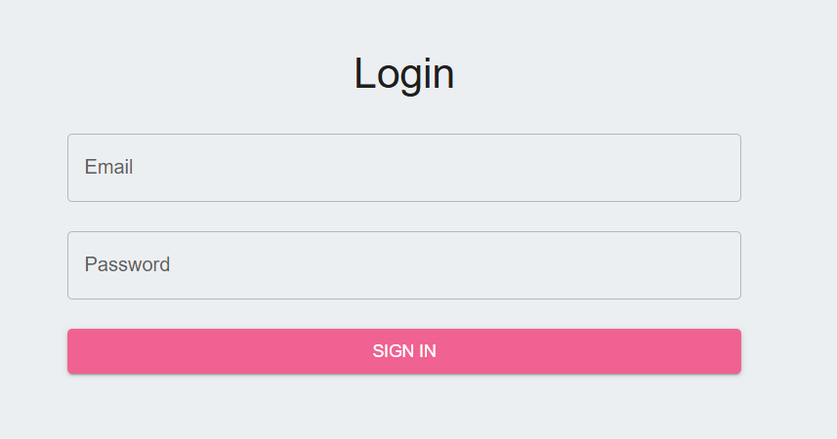

Figure 2.0

**What to Do If You Have Trouble:**

If you see an error message, double-check that you typed your username and password correctly.

If you've forgotten your password, look for a "Forgot Password" or "Reset Password" link on the login screen. Or contact your system administrator.

If you still can't log in, please contact your system administrator or support team for assistance.

**Option 2 - Sign Up**

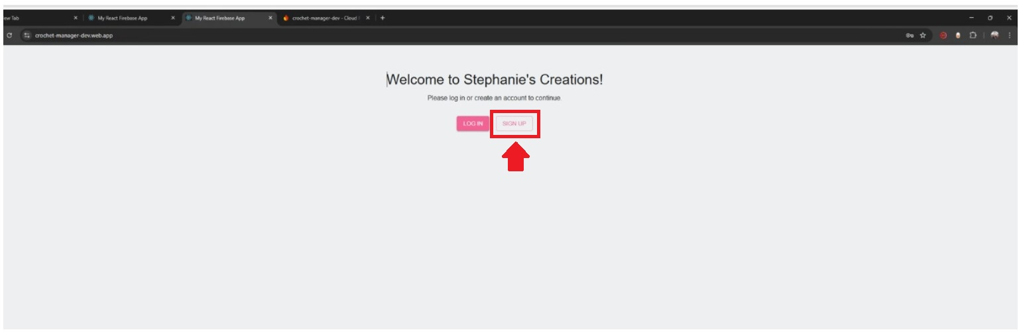

Figure 2.1

**1. Find the Sign Up Button:**

Look for the "SIGN UP" button on the main screen.

It's a **white SIGN UP button**.

Click the **white SIGN UP button** with your mouse.

**2. Create a Username:**

A new screen will appear.

In the box labeled "Username," type in the username you want to use.

**Important:** Choose a username that's easy for you to remember. It might need to be unique, so if it's already taken, the system will tell you.

**3. Create a Password:**

In the box labeled "Password," type in the password you want to use.

**Important:**

Choose a strong password to keep your account safe. A strong password usually includes a mix of letters (both uppercase and lowercase), numbers, and symbols.

Your password will likely appear as dots or stars for security reasons. Type it carefully!

Write down your password in a safe place, so you don't forget it.

**4. Finish Signing Up:**

Once you've entered your username and password, look for the "Sign Up" or "Create Account" button.

It is a **dark pink sign in button**.

Click the **dark pink sign in button** with your mouse.

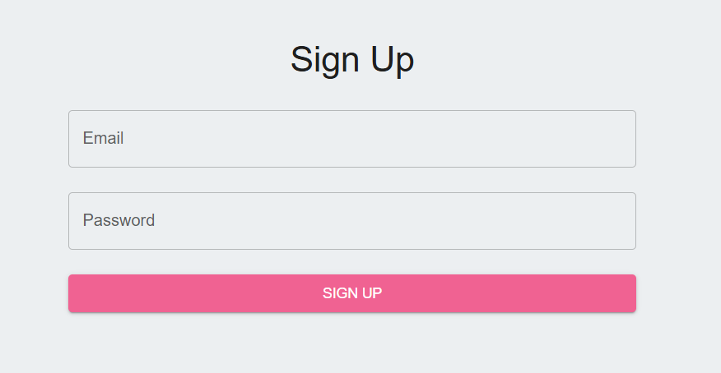

Figure 2.2

**5. Logging in for the First Time:**

After you click the sign in button, you may be automatically logged in, or you may be taken to a login page.

If you are taken to a login page, type in the username and password you just created.

Click the login button.

**Crochet Manager - Orders**

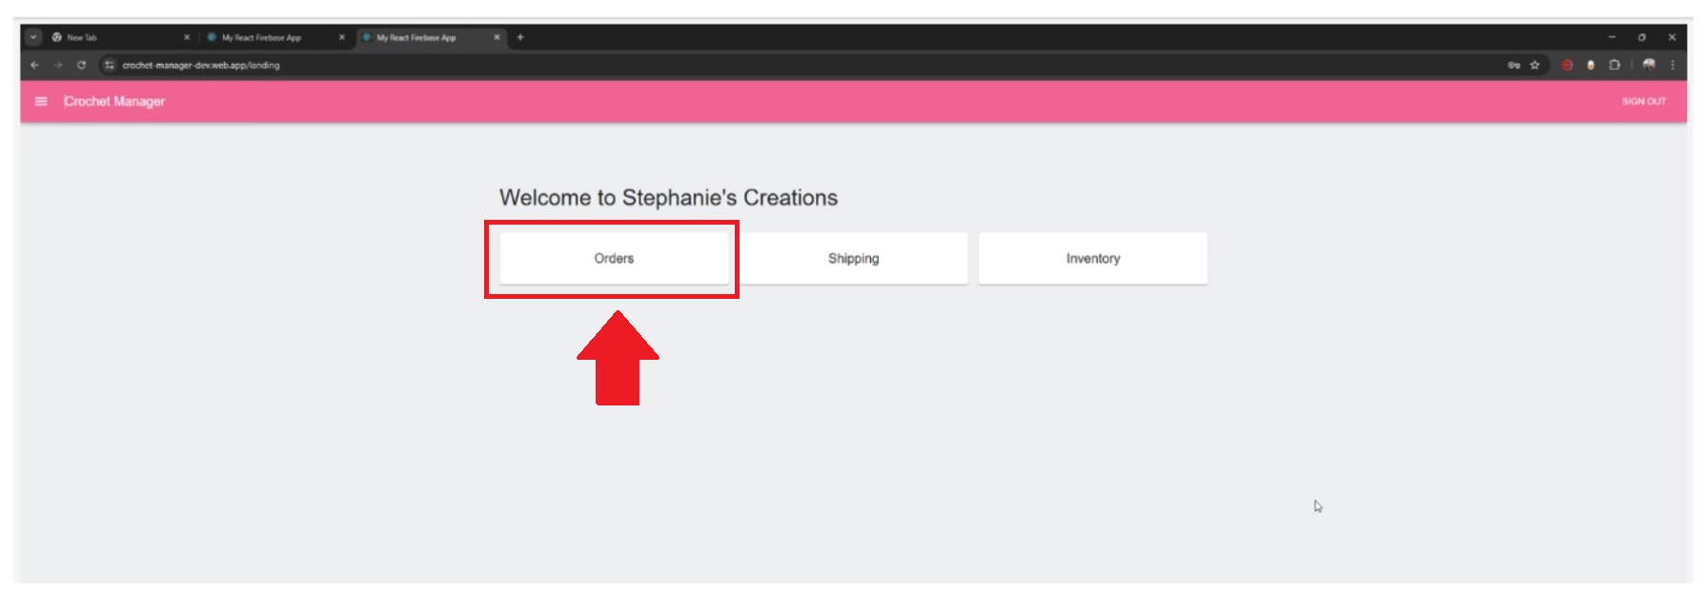

Figure 3.0

**1. Go to the Order Page:**

Look for the "Order" button on the main screen. It might be located on the side menu or at the top of the page.

Click the **"Order" button** with your mouse.

**2. Enter Your Name:**

You'll see two boxes, one labeled "First Name" and the other labeled "Last Name."

In the "First Name" box, type in your first name.

In the "Last Name" box, type in your last name.

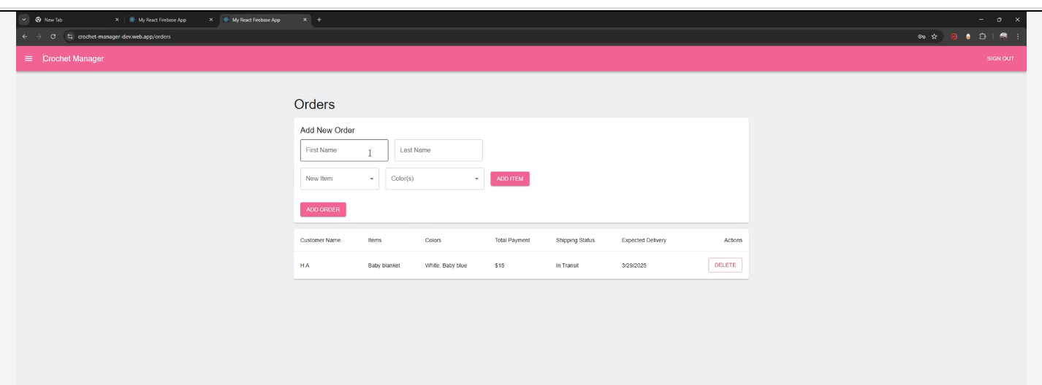

Figure 3.1

**3. Choose Your Item:**

Look for a box labeled "New Item."

To the right of the box, you'll see a small arrow pointing down (a drop-down arrow).

Click the **drop-down arrow**. A list of items will appear.

Click on the item you want to order from the list.

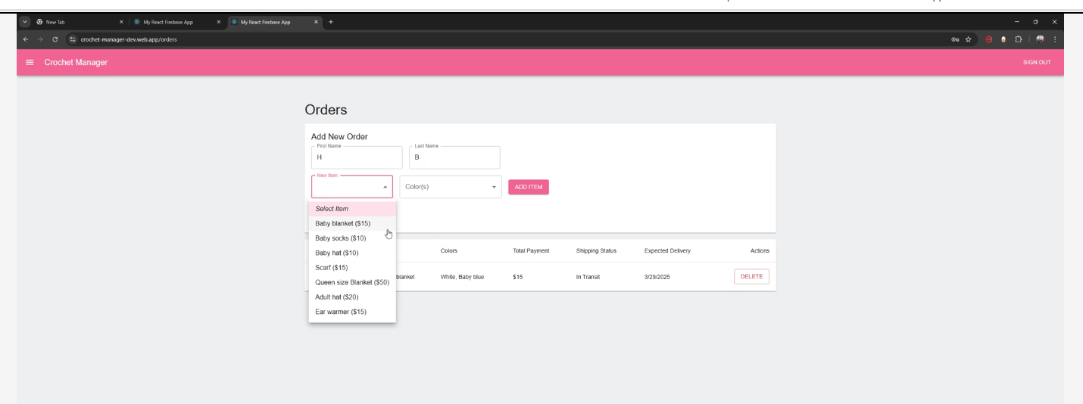

Figure 3.2

**4. Choose Your Color(s):**

Look for a box labeled "Color(s)."

Just like with the item selection, click the **drop-down arrow** next to the box.

A list of colors will appear.

Click on the color(s) you want. If you can choose multiple colors, click on each color you'd like.

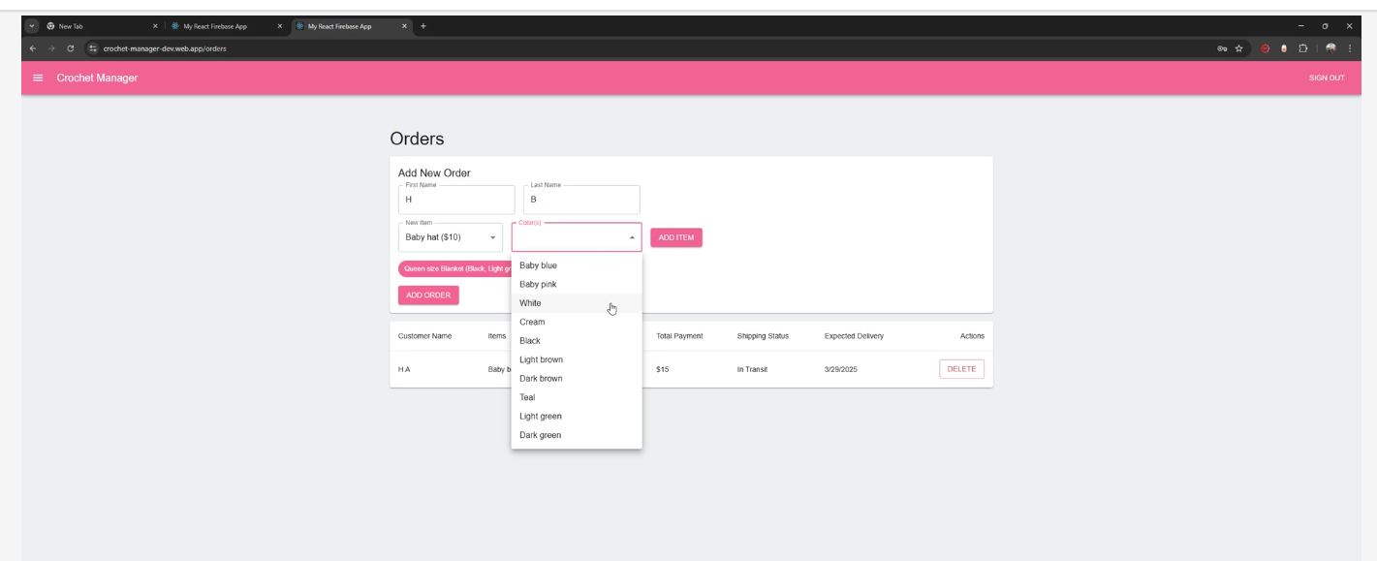

Figure 3.3

**5. Add the Item to Your Order:**

Once you've selected your item and color(s), look for the "Add Item" button.

Click the **"Add Item" button**.

Your selected item and color(s) will be added to your order summary on the screen.

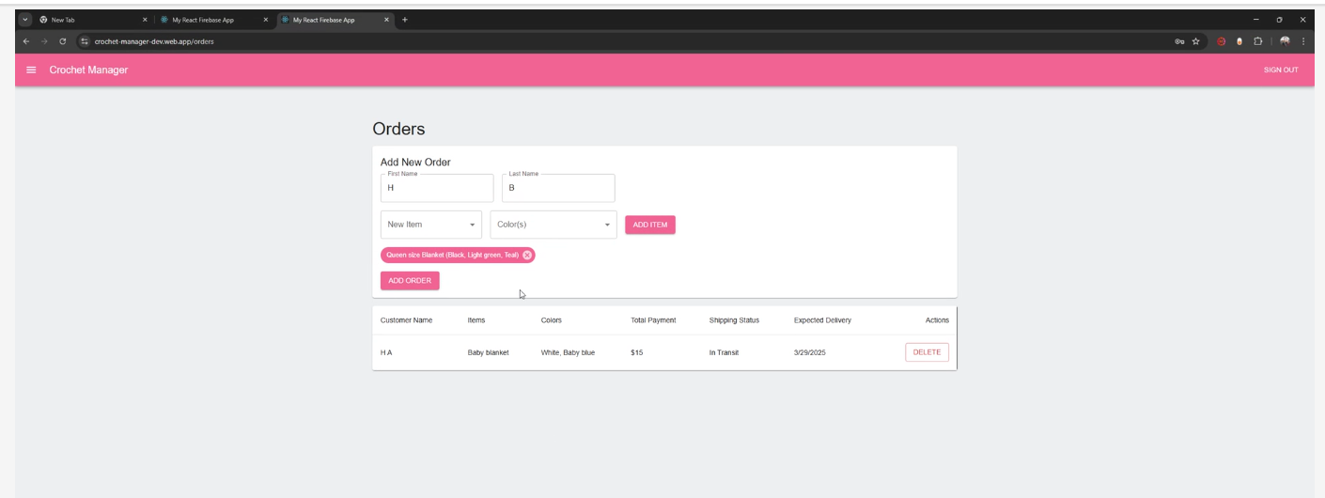

Figure 3.4

**6. Making Changes (If Needed):**

If you want to change any of the items or colors you've added, look for the "Delete" button.

Click the **"Delete" button**. This will remove the item from your order.

Then, repeat steps 3, 4, and 5 to add the correct items and colors.

**7. Finalize Your Order:**

Once you're happy with all the items and colors in your order, look for the "Add Order" button.

Click the **"Add Order" button**.

Your order will be submitted! You may see a confirmation message on the screen.

**Crochet Manager - Shipping**

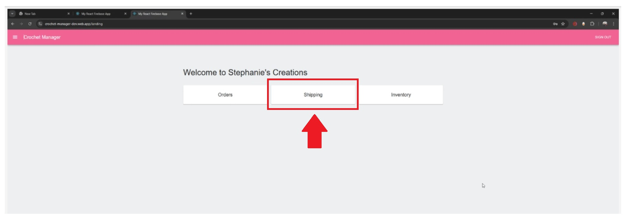

Figure 4.0

**1. Go to the Shipping Page:**

From the Crochet Manager main screen, look for the "Shipping" button.

Click the **"Shipping" button** with your mouse.

**2. Find the Order You Want to Update:**

You'll see a list of customer orders that need to be shipped.

Each order shows:

The customer's name.

The items they ordered.

The total payment amount.

The expected delivery date.

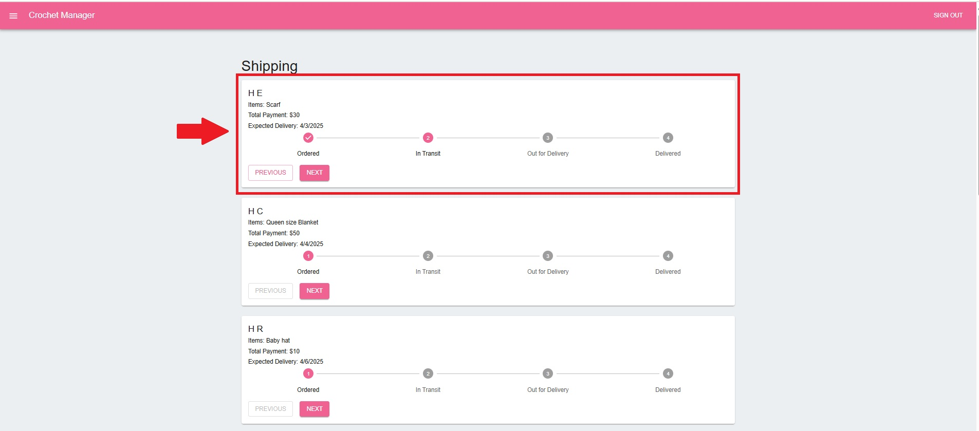

Figure 4.1

**3. Change the Order Status (Moving Forward):**

To update the order's status and move it forward in the shipping process (for example, from "Ordered" to "In Transit"), look for the **dark pink "NEXT" button** next to the order.

Click the **dark pink "NEXT" button** once with your mouse.

Each time you click the **dark pink "NEXT" button**, the order's status will change to the next step in the shipping process:

"Ordered" -> "In Transit"

"In Transit" -> "Out for Delivery"

"Out for Delivery" -> "Delivered"

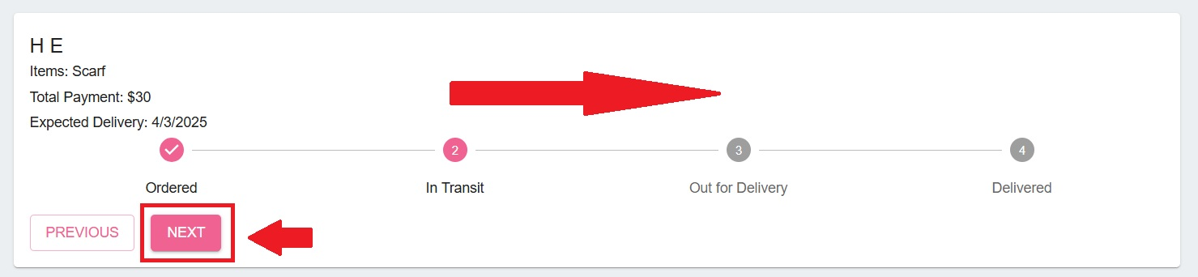

Figure 4.2

**4. Change the Order Status (Moving Backward):**

If there's an unexpected delay or problem, you might need to move the order's status back.

To move the status backward, look for the **white "PREVIOUS" button** next to the order.

Click the **white "PREVIOUS" button** once with your mouse.

Each time you click the **white "PREVIOUS" button**, the order's status will move back one step in the shipping process.

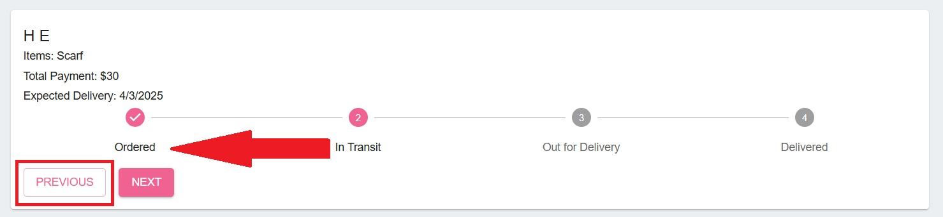

Figure 4.3

**Important Notes:**

Remember, one click of the **"NEXT"** or **"PREVIOUS"** button moves the order's status one step at a time.

Make sure you're selecting the correct order before changing its status.

**Crochet Manager - Inventory**

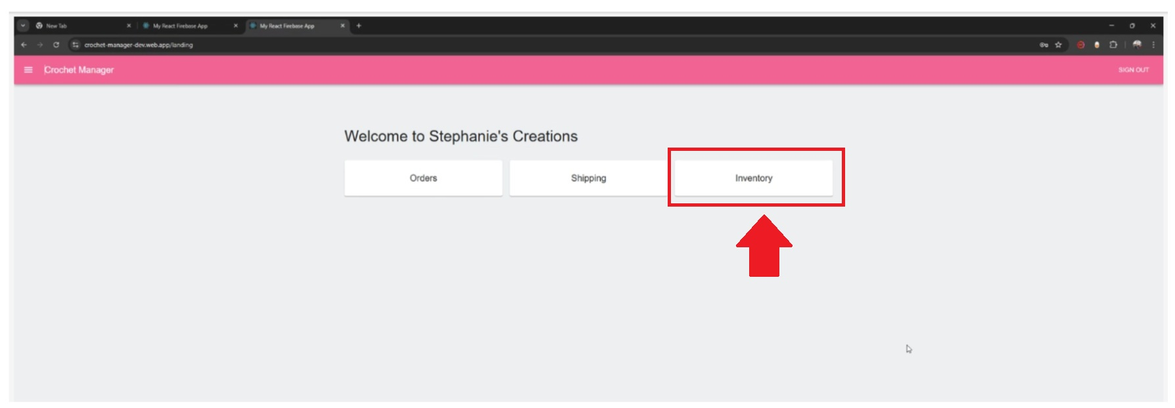

Figure 5.0

**1. Go to the Inventory Page:**

First, make sure you're on the Crochet Manager Home Page.

Look for the "Inventory" button on the main screen.

Click the **"Inventory" button** with your mouse.

**2. Adding a New Item to Inventory:**

You'll see several boxes where you can enter information about a new item.

**3. Enter the Product Name:**

In the box labeled "Product Name," type in the name of the item. For example, "Crochet Scarf" or "Yarn Ball."

**4. Assign an SKU Number:**

In the box labeled "SKU," type in a unique number for this item.

**Important:** An SKU is like an ID number for your item. Make sure you use a different SKU for each different item. Don't use the same SKU for two different product names.

**5. Enter the Quantity:**

In the box labeled "Quantity," type in the number of these items you have in stock. For example, if you have 50 scarves, type "50."

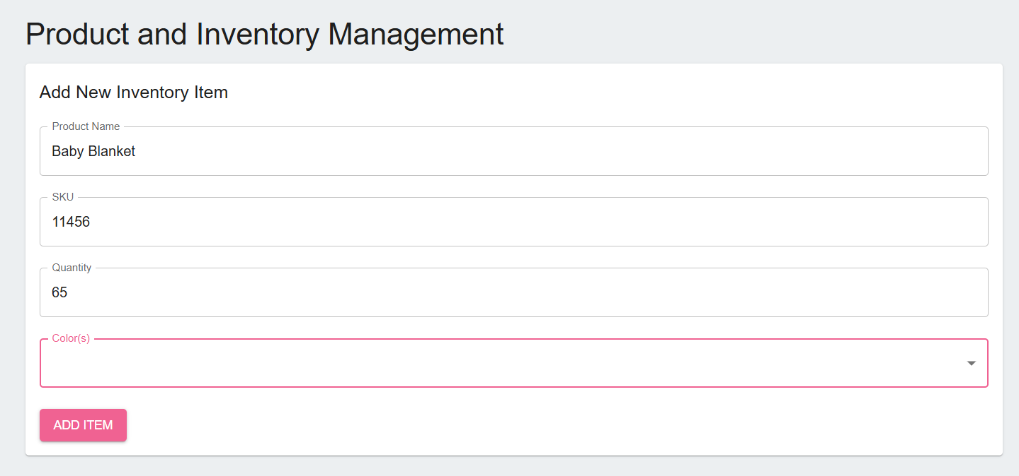

Figure 5.1

**6. Select the Color(s):**

Look for the box labeled "Color(s)."

Click the **drop-down arrow** next to the box. A list of colors will appear.

Click on the color(s) you have in stock for this item. If you have multiple colors, click on each color.

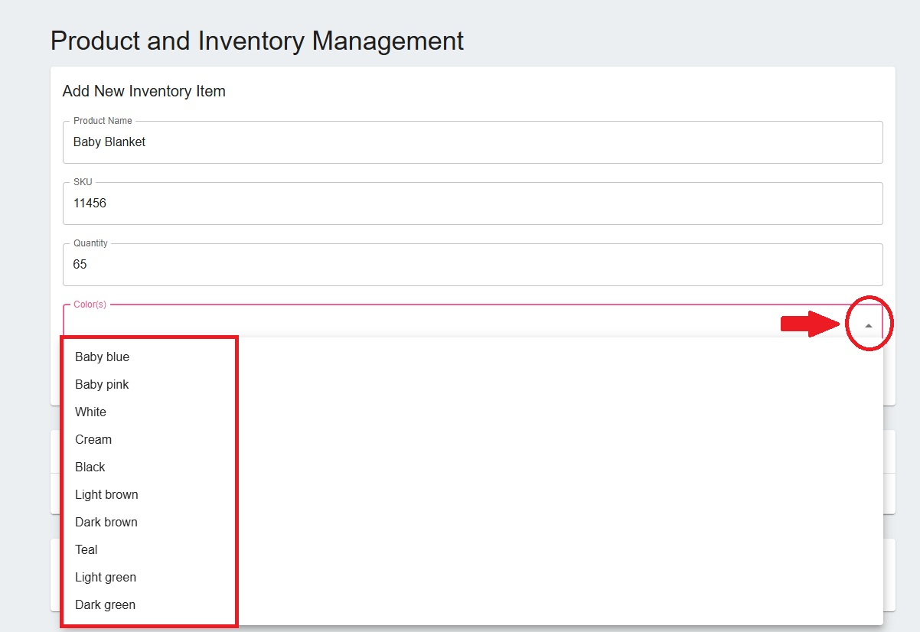

Figure 5.2

**7. Add the Item to Inventory:**

Once you've entered all the information, click the **"Add Item" button**.

The item and its inventory details will appear in the window below.

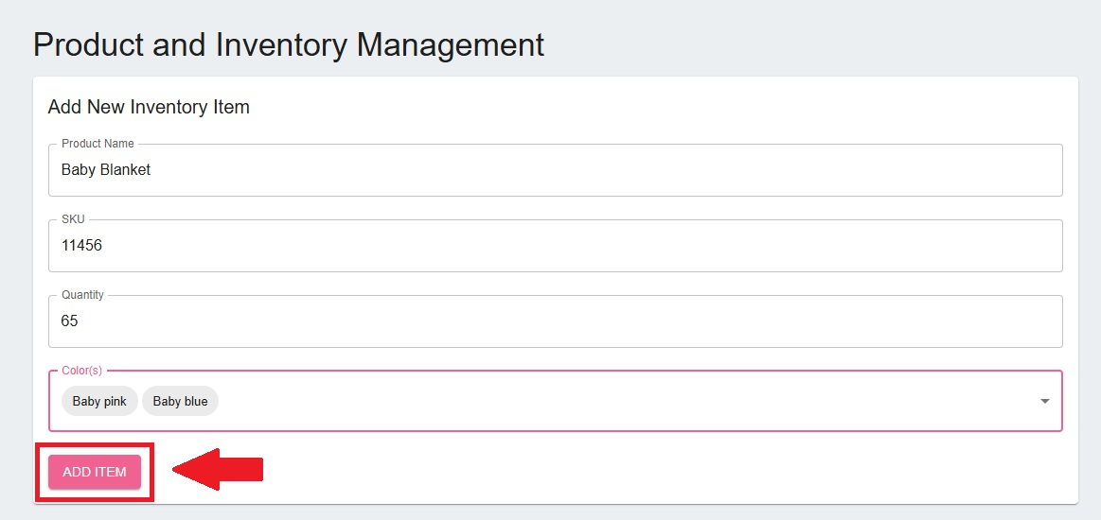

Figure 5.3

**8. Low Stock Alerts:**

Look for the "Low Stock Alert" window.

If any items have a quantity of less than 30, they will be listed here.

If all items have more than 30, you'll see the message: "No low-stock colors."

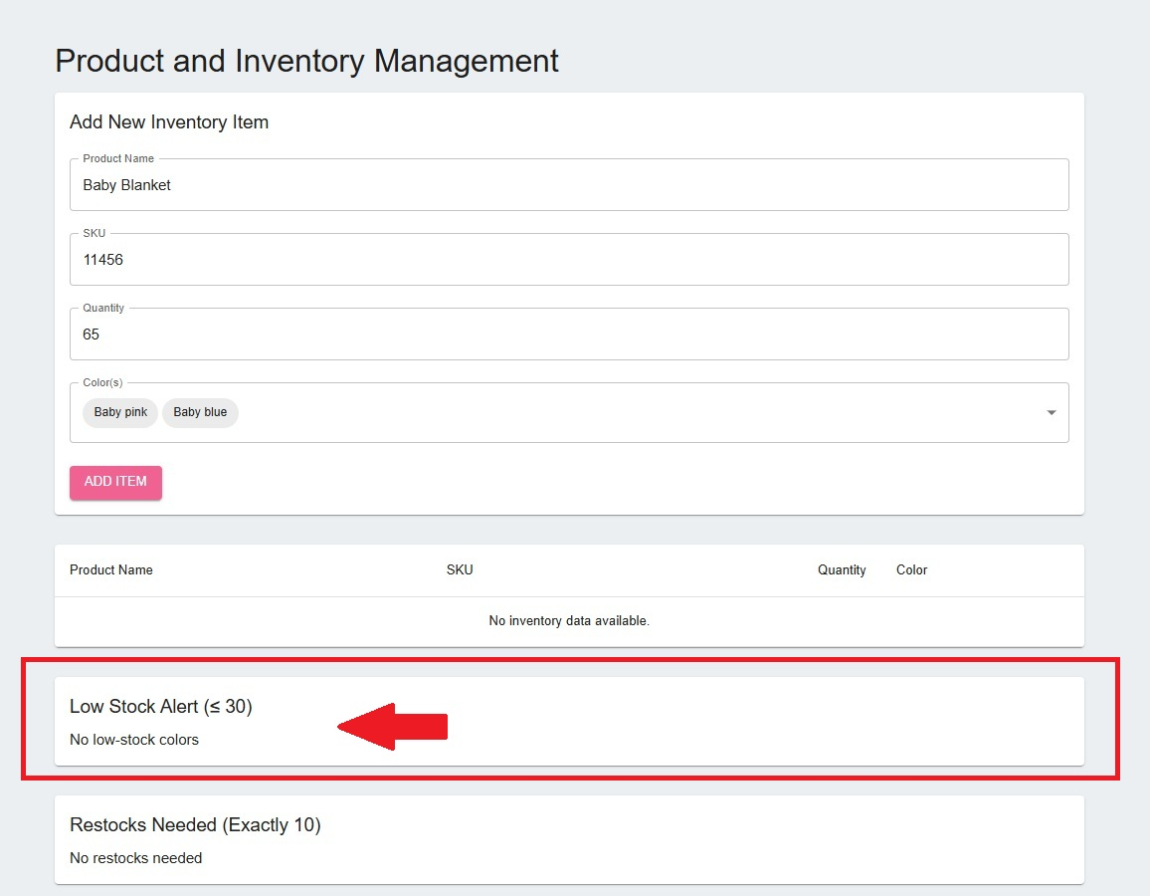

Figure 5.4

**9. Restocks Needed:**

Look for the "Restocks Needed" window.

If any items have a quantity of 10 or less, they will be listed here.

If all items have more than 10, you'll see the message: "No restocks needed."

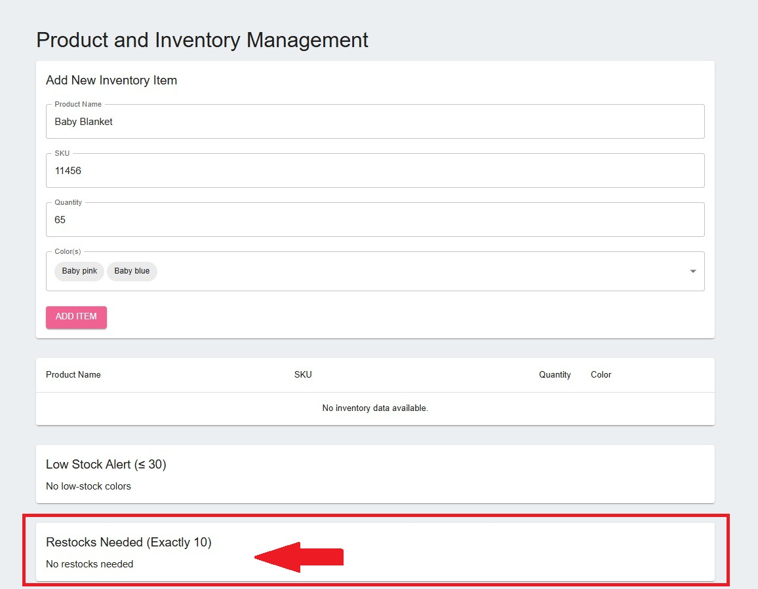

Figure 5.5

**Navigating to the Crochet Manager Home Page**

**1. Find the Menu Button:**

Look at the top of your screen. You'll see a dark pink banner (a long, rectangular bar).

On the left side of the banner, next to the words "Crochet Manager," you'll see a small button with **three parallel horizontal lines**. This is often called a "hamburger menu" because it looks a bit like a hamburger.

**2. Open the Menu:**

Click on the **hamburger menu** (the three lines) with your mouse.

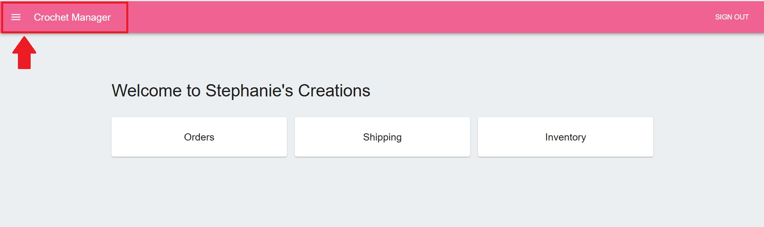

Figure 6.0

**3. Choose a Page:**

A white side-bar will slide open on the left side of your screen.

This menu lists the different sections of Crochet Manager.

You can click on:

**Home:** To go to the main Crochet Manager page.

**Orders:** To view and manage customer orders.

**Shipping:** To handle shipping information.

**Inventory:** To see and manage your inventory.

**4. Go to the Home Page (or Another Page):**

To go to the Home Page, click on the word **"Home"** in the side menu.

To go to a different page, click on the word for that page (e.g., "Orders," "Shipping," or "Inventory").

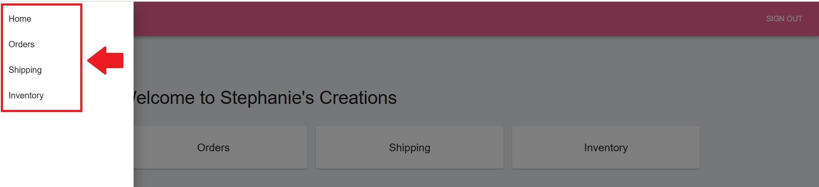

Figure 6.1

**Sign Out**

**1. Find the Sign Out Button:**

Look at the top right corner of your screen. You'll see the dark pink banner (the long, rectangular bar).

In the top right corner of that dark pink bar, you'll see the words **"Sign Out"**.

**2. Click the Sign Out Button:**

Click on the **"Sign Out"** words with your mouse.

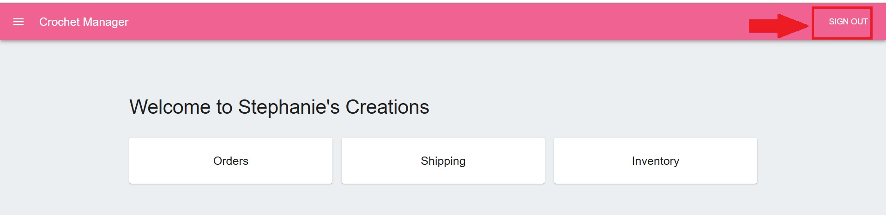

Figure 6.2

**3. Confirmation:**

You will be immediately signed out of Crochet Manager.

You will be taken back to the login or sign-up page. This confirms that you have successfully signed out.

## Technical Manual



Introduction

**System Overview and Purpose**

Stephanie’s Creations—a homegrown crochet business that began as a hobby during the COVID-19 pandemic and evolved into a passion-driven small business. Section 1 examines the current manual processes and identifies opportunities for improvement through problem analysis, proposed system objectives, constraints, and expected benefits.

The new system will introduce inventory tracking, sales management, customer data storage, and e-commerce integration, focusing on ease of use, affordability, and scalability. Expected benefits include increased efficiency, improved organization, and enhanced customer service, enabling Stephanie to expand her business and continue her philanthropic efforts.

**Target Audience**

Given Stephanie’s current manual workflow, our team recommends a Business Process Improvement (BPI) approach rather than a full Business Process Reengineering (BPR) overhaul. Since she already has an informal system in place and plans to expand to an online platform, refining her existing operations is more practical than a complete restructuring.

While Business Process Automation (BPA) may be considered in the future to streamline tasks such as customer engagement and predictive inventory tracking, our immediate focus is on enhancing system usability and optimizing core processes for efficiency.

|  |  |
| --- | --- |
| System Objectives | |
| User-Friendly Interface | The system should be intuitive and easy to navigate, requiring minimal technical knowledge. |
| Inventory Management | Enable efficient tracking of available stock, materials, and finished products. |
| Sales Tracking | Provide tools for recording transactions, monitoring sales trends, and generating reports. |
| Customer Management | Maintain customer details, including order history, preferences, and shipping information, to enhance service. |
| E-commerce Integration | Support seamless integration with online marketplaces to streamline product listings and order processing. |
| Cost-Effective Solution | Minimize recurring costs while maintaining essential functionality. |
| Security & Compliance | Ensure secure storage of customer payment details and personal information in compliance with industry standards. |

|  |  |
| --- | --- |
| System Constraints | |
| Budget Limitations | The system must operate within financial constraints, including hosting, payment processing, and potential subscription fees. |
| Accessibility Considerations | Design must accommodate various visual needs, ensuring readability and ease of use. |
| Limited Technical Expertise | The system should require minimal maintenance and technical knowledge. |
| Scalability | While initially designed for small-scale operations, the system should allow for future expansion. |
| Platform Compatibility | The system should integrate seamlessly with potential websites or e-commerce platforms. |

**System Requirements**

**Supplement Specifications (Non-Functional)**

**Operational Specifications**

**1.1 Training and Support:**

**1.1.1 Minimal Training Requirement:** The system shall be designed to minimize end-user training. Stephanie shall be able to perform core functions with no more than 1 hour of initial training.

**1.1.2 Intuitive User Interface:** The user interface shall adhere to established usability guidelines, employing clear labels, consistent navigation, and logical workflows.

**1.1.3 Contextual Help:** Contextual help shall be available for all features, providing on-screen guidance and explanations.

**1.1.4 User Manual and Support Tools:** A comprehensive user manual, FAQ, and video tutorials shall be provided to support Stephanie in using the system.

**1.2 Accessibility:**

**1.2.1 Font and Contrast:** The system shall utilize font sizes and color contrasts that meet WCAG (Web Content Accessibility Guidelines) AA standards.

**1.2.2 Screen Reader Compatibility:** The system shall be compatible with commonly used screen reader software.

**1.2.3 Adjustable Font Sizes:** The system shall allow users to adjust font sizes to accommodate visual needs.

**1.3 System Maintenance:**

**1.3.1 Scheduled Maintenance:** Scheduled maintenance shall be performed during off-peak hours to minimize disruption to Stephanie's business.

**1.3.2 Maintenance Notifications:** Stephanie shall receive advance notification of scheduled maintenance.

**Performance Specifications**

**2.1 Response Time:**

**2.1.1 Key Operations:** Key operations (add inventory, process sale, generate report) shall have a response time of ≤ 2 seconds under normal load conditions.

**2.1.2 Page Load Time:** Web page load times shall be ≤ 3 seconds.

**2.2 Scalability:**

**2.2.1 Transaction Volume:** The system shall be able to handle a 50% increase in transaction volume within the first year without exceeding the 2-second response time requirement.

**2.2.2 Inventory and Customer Records:** The system shall accommodate a 50% increase in inventory items and customer records within the first year without significant performance degradation (defined as a response time increase of > 0.5 seconds).

**2.3 Availability:**

**2.3.1 Uptime:** The system shall maintain 99.5% uptime, excluding scheduled maintenance windows.

**2.3.2 Monitoring:** System availability shall be continuously monitored, and alerts shall be generated for any downtime.

**2.4 Data Capacity:**

**2.4.1 Storage:** The system shall have storage capacity to accommodate three years of transaction data, customer information, and inventory records.

**2.4.2 Database Performance:** Database queries shall be optimized to maintain performance as data volume increases.

**Security Specifications**

**3.1 Data Encryption:**

**3.1.1 Encryption in Transit:** All sensitive data transmitted over the network shall be encrypted.

**3.1.2 Encryption at Rest:** Customer payment information and personal details shall be encrypted at rest.

**3.1.3 Key Management:** Encryption keys shall be securely managed and stored.

**3.2 Access Control:**

**3.2.1 Role-Based Access Control (RBAC):** The system shall implement RBAC, with predefined roles and permissions.

**3.2.2 Authentication:** Users shall be authenticated using strong passwords and/or multi-factor authentication (MFA).

**3.2.3 Authorization:** Stephanie shall have full administrative privileges. Future roles and permissions shall be configurable.

**3.3 Data Backup and Recovery:**

**3.3.1 Automated Backups:** Automated backups shall be performed daily and stored offsite.

**3.3.2 Recovery Time Objective (RTO):** The system shall be recoverable within 24 hours.

**Cultural/Political Specifications**

**4.1 Data Privacy Compliance:**

**4.1.1 Compliance with Relevant Laws, (e.g., GDPR, CCPA):** The system shall comply with all applicable data privacy laws and regulations.

**4.1.2 Privacy Policy:** A clear and concise privacy policy shall be provided to users.

**4.1.3 Data Subject Rights:** The system shall support data subject rights, including the right to access, rectify, and delete personal data.

**4.2 E-commerce Integration:**

**4.2.1 API Integration:** The system shall utilize secure and well-documented APIs for integration with chosen e-commerce platforms.

**4.2.2 Data Synchronization:** Data synchronization between the system and e-commerce platforms shall be reliable and efficient.

**4.3.3 Business continuity:** The system will be designed to allow for easy transition to new platforms, or e-commerce sites, should the need arise.

**Hardware and Software Specification**

To ensure our system is accessible and user-friendly, we have designed it with minimal hardware and software requirements. This approach is driven by our commitment to client and end-user needs, prioritizing ease of use and broad compatibility. By keeping the requirements simple, we enable a wider range of users to access our system without the need for specialized equipment, thus enhancing user engagement and satisfaction.

**Hardware Requirements**

* Any laptop or mobile device that can connect to the internet
* Router to connect to the internet

**Software Requirements**

* Any laptop or mobile device that can connect to the internet

This streamlined setup ensures that our system is functional and efficient across various devices and internet connections, facilitating seamless integration into users' daily operations.

**System Architecture**

Detailed Diagrams

Use Case Diagram

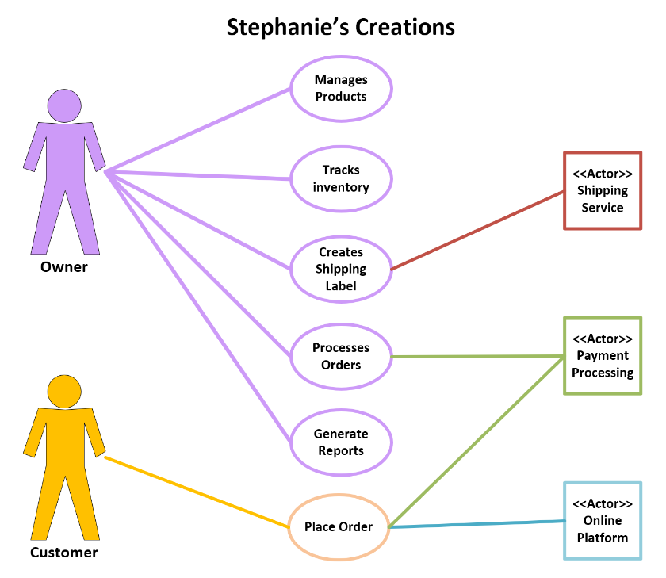

Complete Data Flow Diagram Package

**Context Diagram**

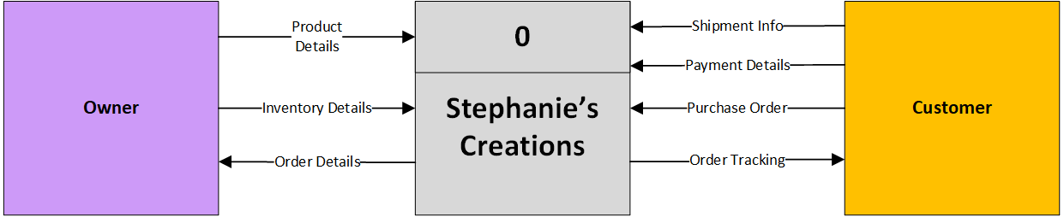

**Level 0 Diagram**

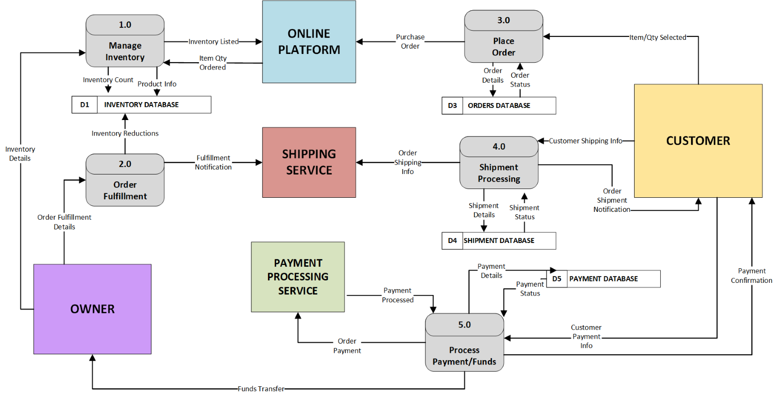

**Level 1 Diagram – Process 1.0**

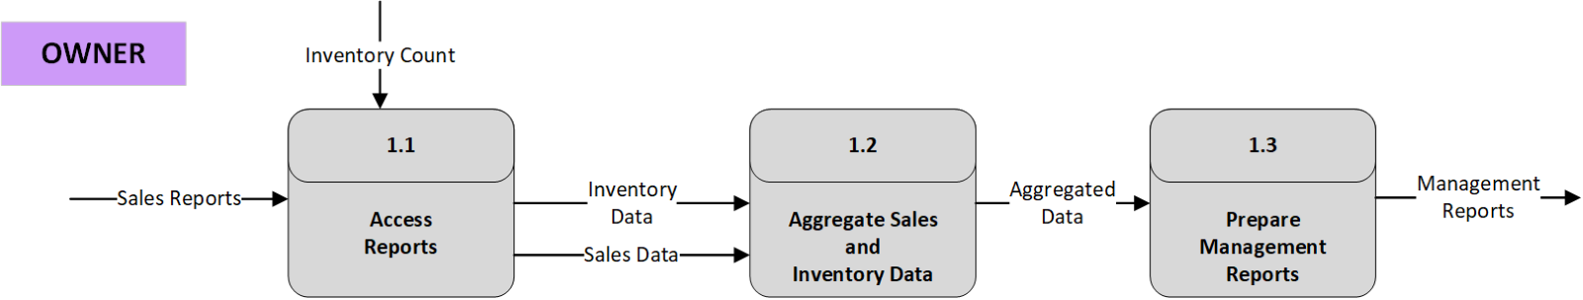

**Level 1 Diagram – Process 3.0**

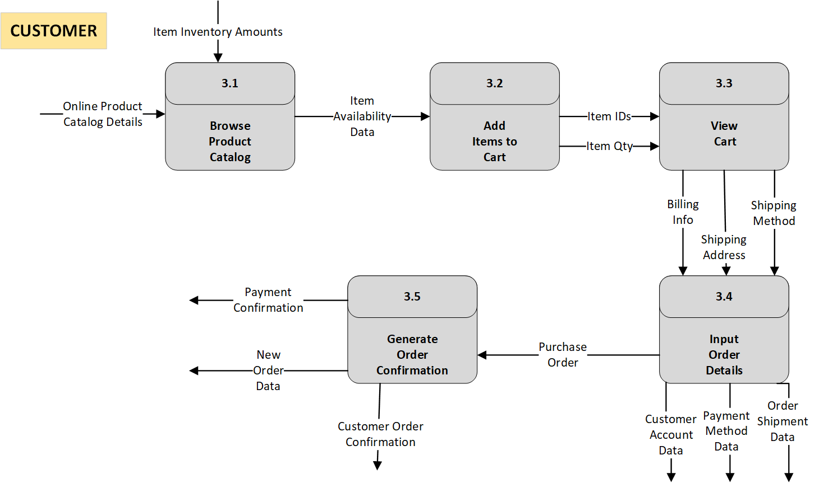

Database schema

Entity Relationship Diagram

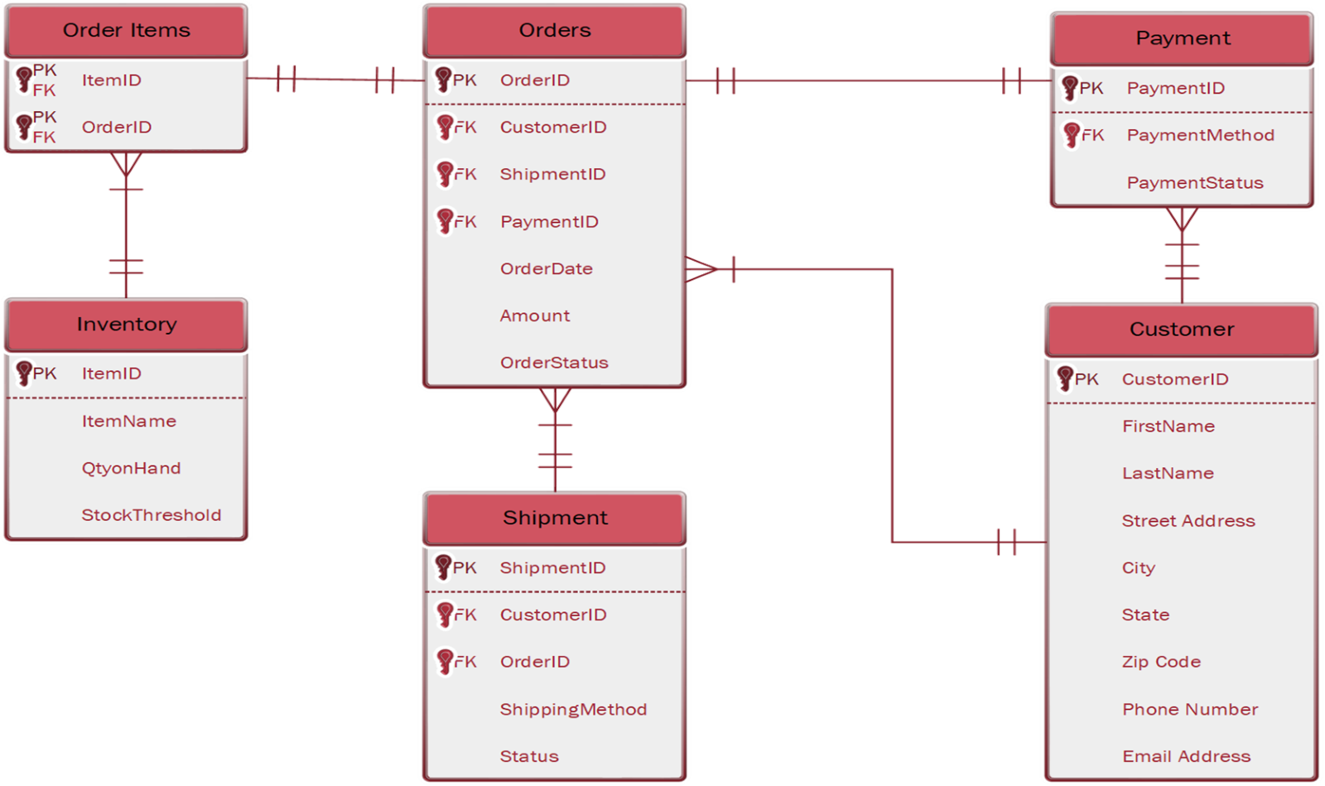

Operational Procedures

Detailed Descriptions of System Functions

**1. User Authentication and Account Management**

**1.1. User Login (Option 1):**

**Function:** Authenticates existing users for system access.

* **Process:**
  + The system presents a login interface with "Username" and "Password" input fields.
  + Upon user submission (via the "LOGIN" and "Sign In" buttons), the system validates credentials against the user database.
  + Successful authentication grants access to the system's functionalities.
  + Failed authentication triggers an error message, prompting the user to re-enter credentials or initiate password recovery.
  + **Data Handling:**
    - Usernames and hashed passwords are retrieved from and compared to the user database.
    - Session management is initiated upon successful login.
  + **Error Handling:**
    - Incorrect username/password combinations result in an error message.
    - Provides links to password reset/recovery functionality.

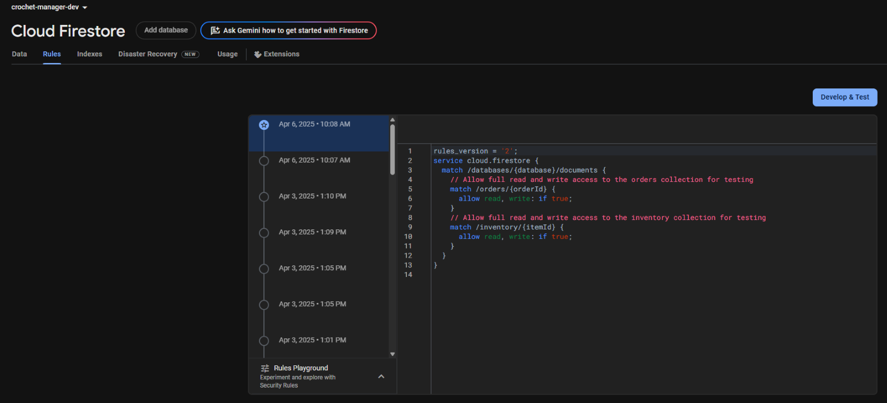

Figure 1.0   
Firestore Rules

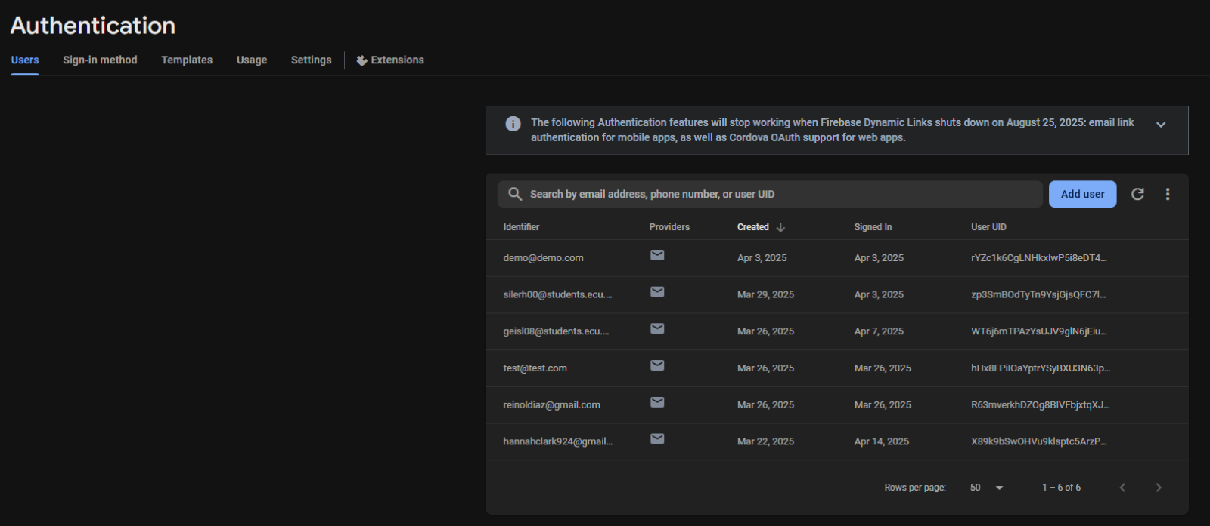

Figure 1.1   
Authentication

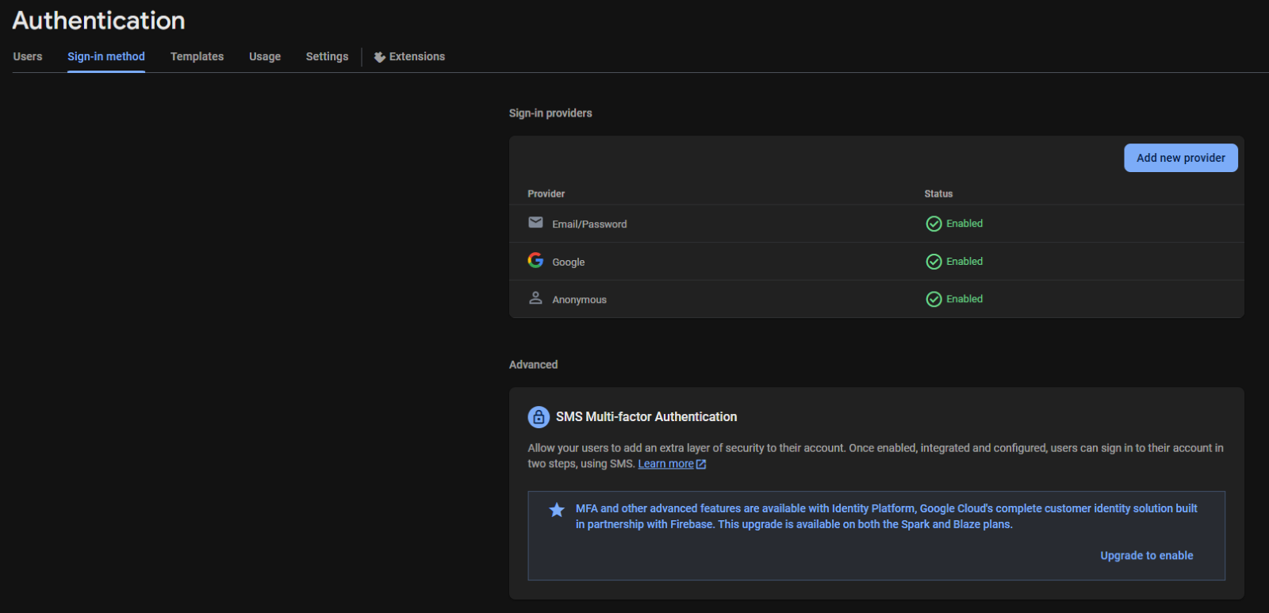

Figure 1.2  
Authentication

**1.2. User Registration (Sign Up - Option 2):**

**Function:** Enables new users to create system accounts.

* **Process:**
  + The system provides a registration interface with "Username" and "Password" input fields.
  + The system validates the username for uniqueness against the user database.
  + The system validates the password based on security requirements.
  + Upon submission (via the "SIGN UP" and "dark pink sign in" buttons), the system creates a new user record in the user database.
  + The user is then either automatically logged in, or redirected to the log in screen.
* **Data Handling:**
  + Usernames and hashed passwords are stored in the user database.
  + The system manages the creation of unique user ID's.
* **Error Handling:**
  + Duplicate usernames trigger an error message.
  + Weak passwords trigger an error message with password complexity requirements.

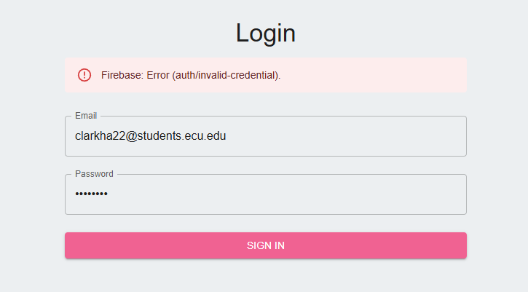

Figure 1.3  
Authentication Error

**2. Order Management (Crochet Manager - Orders)  
Function:** Facilitates the creation and management of customer orders.

* **Process:**
  + The system presents an order creation interface with fields for customer name, item selection, and color selection.
  + Users select items and colors from drop-down menus, which populate data from the product and color databases.
  + The "Add Item" button adds selected items to an order summary.
  + The "Delete" button removes selected items from the order summary.
  + The "Add Order" button submits the order, storing order details in the order database.
  + The system may display a confirmation message upon successful order submission.
* **Data Handling:**
  + Customer names are stored as text.
  + Item and color selections are linked to corresponding records in the product and color databases.
  + Order details are stored in the order database, including customer information, item IDs, color IDs, and order status.
* **Data Validation:**
  + Data validation occurs when selecting from drop down menus, ensuring that valid product and color ID's are used.

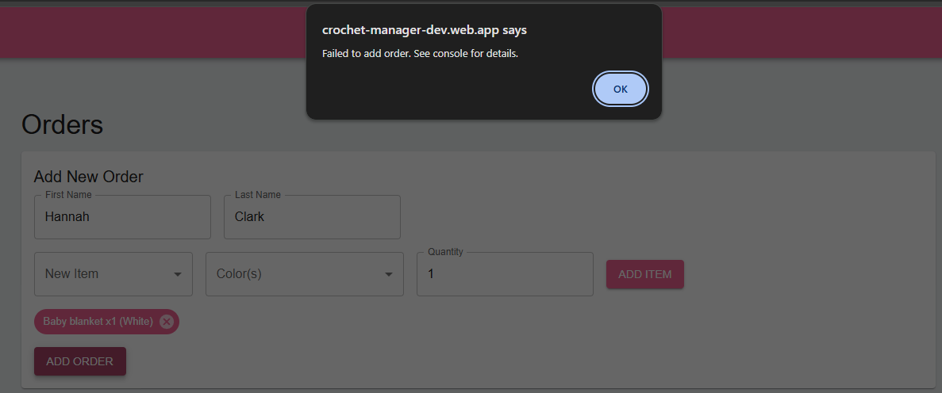

Figure 2.0  
Permissions Error

**3. Inventory Management (Crochet Manager - Inventory)  
Function:** Manages product inventory levels.

* **Process:**
  + The system provides an inventory management interface with fields for product name, SKU, quantity, and color selection.
  + Users input product information, including a unique SKU.
  + The system validates the SKU for uniqueness against the product database.
  + The "Add Item" button adds the product and its inventory details to the inventory database.
  + The system displays low stock alerts (quantity < 30) and restock alerts (quantity <= 10) in separate windows.
* **Data Handling:**
  + Product names, SKUs, quantities, and color selections are stored in the inventory database.
  + The system performs queries to identify low stock and restock items.
* **Data Validation:**
  + SKU uniqueness is validated against the product database.
  + Quantity values are validated as numerical inputs.

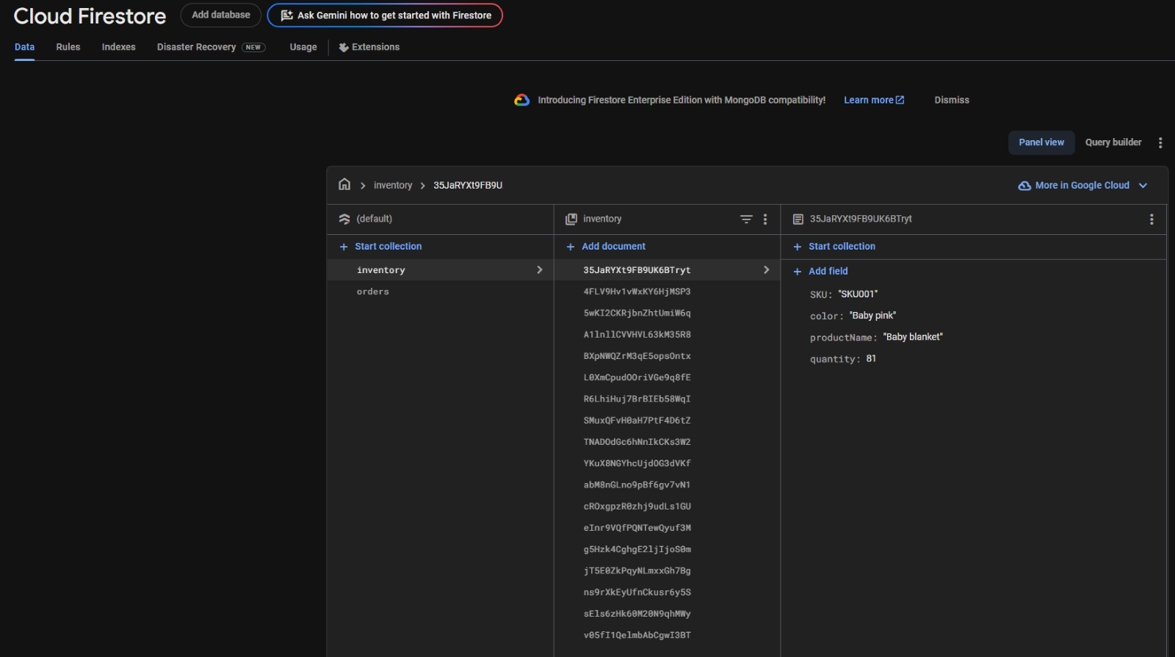

Figure 3.0   
Data input successfully

**4. System Navigation  
Function:** Provides navigation between system modules.

* **Process:**
  + The system displays a navigation menu (hamburger menu) in the top banner.
  + Clicking the hamburger menu opens a side navigation bar.
  + Users select modules (Home, Orders, Shipping, Inventory) from the side navigation bar.
  + The system loads the selected module's interface.

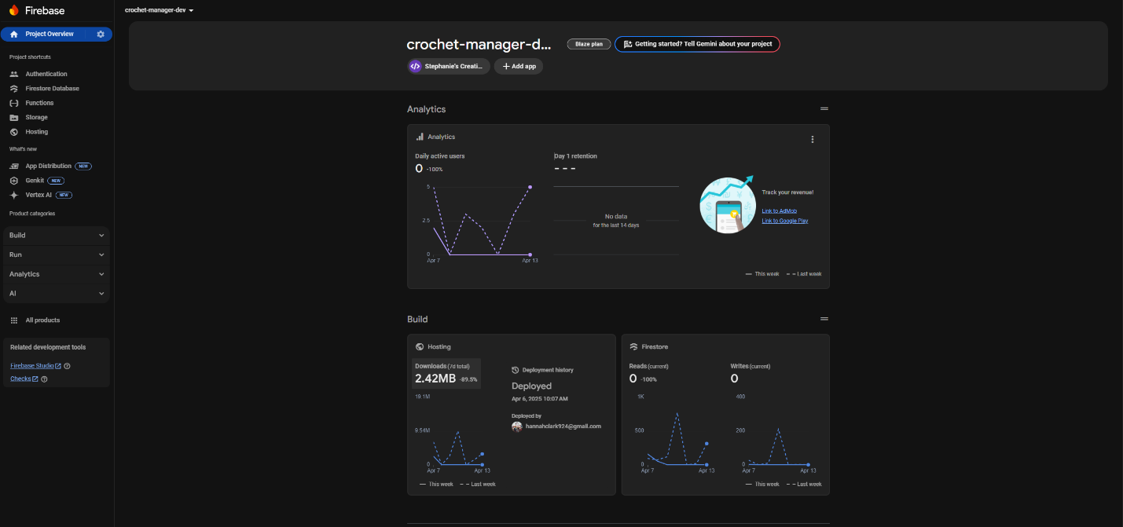

Figure 4.0  
Firebase console

**5. User Logout  
Function:** Terminates user sessions.

* **Process:**
  + The system displays a "Sign Out" button in the top right corner.
  + Clicking the "Sign Out" button terminates the user's session.
  + The system redirects the user to the login/sign-up page.
* **Data Handling:**
  + The current user session is destroyed.

**Input and Output Specifications**

Program Plan – IPO Chart

|  |  |  |  |
| --- | --- | --- | --- |
| Program | Inputs | Outputs | Processing Steps |
| Home Page | * Orders Table * Shipment Tracking * Inventory Overview | * Order Status * Shipment Tracking * Inventory Summary | 1. Fetch data from Orders, Shipments, and Inventory 2. Aggregate and format data 3. Display results |
| Orders Table | * Customer Name * Item * Payment | * Order History * Order Status | 1. Validate inputs (name, item, payment) 2. Generate unique Order ID 3. Store order in database 4. Update order status |
| Shipment Tracking | * New Orders * Older Orders | * In-transit Orders * Delayed Shipments * Expected Delivery Dates | 1. Retrieve shipping details from the database 2. Calculate estimated delivery 3. Update shipment status |
| Inventory Overview | * Product Stock Level * Supplier Data | * Low Stock Alerts * Restock Notifications * Updated Stock Levels | 1. Check stock levels 2. Generate restock alerts if needed 3. Update inventory database |

**Data Flow and Processing Logic**

Navigation Diagram

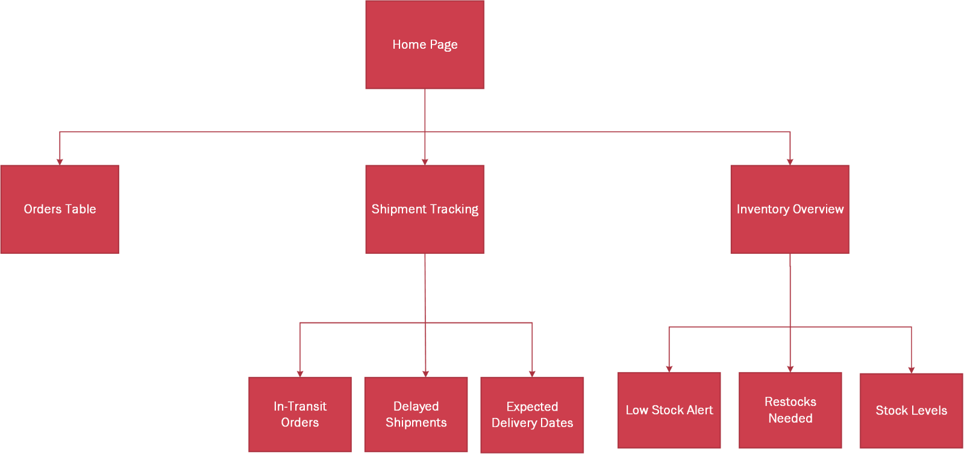

Troubleshooting

Common Issues & Error Messages

**1. Authentication & User Management:**

* **Error:** "Invalid Username or Password."
  + **Description:** Occurs when the user enters incorrect login credentials.
  + **Possible Causes:** Typographical errors, incorrect credentials, account lockout.
  + **Resolution:**
    - Instruct the user to verify their input.
    - Provide instructions for password recovery.
    - Indicate how to unlock an account.
* **Error:** "Username Already Exists."
  + **Description:** Occurs during registration when a user attempts to create an account with an existing username.
  + **Possible Causes:** Duplicate username entries.
  + **Resolution:** Prompt the user to choose a different username.
* **Error:** "Password Does Not Meet Complexity Requirements."
  + **Description:** Occurs during registration when the user's password does not meet the system's security criteria.
  + **Possible Causes:** Weak password.
  + **Resolution:** Provide detailed password complexity requirements (e.g., minimum length, character types).
* **Error:** "Account Locked."
  + **Description:** Occurs when a user has too many failed login attempts.
  + **Possible causes:** repeated failed login attempts.
  + **Resolution:** Document the account lockout procedure, and the time the account will be locked, and how to unlock the account.
* **Error:** "Database Connection Error."
  + **Description:** Occurs when the system cannot connect to the user database.
  + **Possible Causes:** Network issues, database server downtime, incorrect database credentials.
  + **Resolution:** Document the steps to check database server status, network connectivity, and database credentials.

**2. Order Management:**

* **Error:** "Item Not Found."
  + **Description:** Occurs when the user selects an item that does not exist in the product database.
  + **Possible Causes:** Database inconsistencies, incorrect item IDs.
  + **Resolution:** Document the steps to verify product availability in the database.
* **Error:** "Color Not Found."
  + **Description:** Occurs when the user selects a color that does not exist in the color database.
  + **Possible Causes:** Database inconsistencies, incorrect color IDs.
  + **Resolution:** Document the steps to verify color availability in the database.
* **Error:** "Order Submission Failed."
  + **Description:** Occurs when the system cannot save the order to the order database.
  + **Possible Causes:** Database errors, network issues, data validation failures.
  + **Resolution:** Document the steps to check database connection, network connectivity, and data validation rules.

**3. Inventory Management:**

* **Error:** "SKU Already Exists."
  + **Description:** Occurs when the user attempts to add an item with an SKU that already exists in the inventory database.
  + **Possible Causes:** Duplicate SKU entries.
  + **Resolution:** Prompt the user to enter a unique SKU.
* **Error:** "Invalid Quantity."
  + **Description:** Occurs when the user enters a non-numeric value for the quantity.
  + **Possible Causes:** Incorrect data type.
  + **Resolution:** Prompt the user to enter a numeric value.
* **Error:** "Database Write Error."
  + **Description:** Occurs when the system cannot save inventory data to the database.
  + **Possible Causes:** Database errors, network issues, data validation failures.
  + **Resolution:** Document the steps to check database connection, network connectivity, and data validation rules.

**4. Shipping Management:**

* **Error:** "Order Status Update Failed."
  + **Description:** Occurs when the system cannot update the order status.
  + **Possible Causes:** Database errors, network issues, incorrect order IDs.
  + **Resolution:** Document the steps to check database connection, network connectivity, and order IDs.
* **Error:** "Invalid Order ID."
  + **Description:** Occurs when the system cannot find the order ID that it is attempting to change.
  + **Possible causes:** Database error, or incorrect order id being passed to the function.
  + **Resolution:** Check the database for the existance of the order id.
* **5. System Navigation & General Errors:**
* **Error:** "Page Not Found."
  + **Description:** Occurs when the user attempts to access a non-existent page.
  + **Possible Causes:** Broken links, incorrect URLs.
  + **Resolution:** Document the steps to check URLs and navigation links.
* **Error:** "System Error."
  + **Description:** A generic error message indicating an unexpected system failure.
  + **Possible Causes:** Runtime exceptions, unhandled errors.
  + **Resolution:** Document the steps to check system logs, restart services, and contact support.

Non-Routine Situations

**1. Data Corruption/Loss:**

* **Situation:** Database corruption or accidental data deletion.
  + **Description:** Explains the potential impact of data loss on system functionality.
  + **Possible Causes:** Hardware failures, software bugs, human error, security breaches.
  + **Resolution:**
    - Document the system's backup and restore procedures.
    - Provide instructions for database recovery using transaction logs or other recovery tools.
    - Outline the steps to identify and isolate the source of corruption.
    - Document the procedure for data recovery from off site backups.
    - Detail the steps to perform a forensic analysis of the system.
  + **Logging:** Specify the location of relevant database logs and system logs.
  + **Severity:** High (potential for significant data loss and system downtime).

**2. System Performance Degradation:**

* **Situation:** Slow system response times or unexpected system crashes.
  + **Description:** Explains the impact of performance issues on user experience and system stability.
  + **Possible Causes:**
    - Increased system load.
    - Resource exhaustion (CPU, memory, disk space).
    - Network latency.
    - Inefficient database queries.
    - Software bugs.
  + **Resolution:**
    - Document the steps for monitoring system performance (CPU usage, memory usage, network traffic).
    - Provide instructions for analyzing system logs and database query logs.
    - Outline the steps to identify and resolve performance bottlenecks.
    - Document the steps to restart system services.
    - Document procedures for database optimization.
  + **Logging:** Specify the location of system performance logs, database query logs, and network logs.
  + **Severity:** Medium to High (depending on the severity of the performance degradation).

**3. Security Breaches:**

* **Situation:** Unauthorized access to system data or functionality.
  + **Description:** Explains the potential impact of security breaches on data confidentiality, integrity, and availability.
  + **Possible Causes:**
    - Weak passwords.
    - Software vulnerabilities.
    - Malware infections.
    - Social engineering attacks.
  + **Resolution:**
    - Document the incident response plan.
    - Provide instructions for isolating affected systems.
    - Outline the steps for analyzing system logs and network traffic.
    - Document the steps for changing passwords and revoking access.
    - Document the steps to perform a forensic analysis.
    - Document the steps to inform affected users.
  + **Logging:** Specify the location of security logs, system logs, and network logs.
  + **Severity:** High (potential for significant data loss, financial loss, and reputational damage).

**4. Third-Party Integration Failures:**

* **Situation:** Problems with integrations with external systems or APIs.
  + **Description:** Explains the impact of integration failures on system functionality.
  + **Possible Causes:**
    - API changes.
    - Network connectivity issues.
    - Authentication failures.
    - Data format mismatches.
  + **Resolution:**
    - Document the steps for testing API connectivity and functionality.
    - Provide instructions for analyzing API error messages and logs.
    - Outline the steps for troubleshooting network connectivity issues.
    - Document the steps to contact the third party support.
  + **Logging:** Specify the location of API logs, network logs, and system logs.
  + **Severity:** Medium (potential for disruption of specific system functionalities).

**5. System Upgrade/Patching Issues:**

* **Situation:** Problems encountered during system upgrades or patch installations.
  + **Description:** Explains the potential impact of upgrade/patching issues on system stability.
  + **Possible Causes:**
    - Incompatible software versions.
    - Database migration errors.
    - Configuration file conflicts.
    - Interrupted upgrades.
  + **Resolution:**
    - Document the rollback procedures.
    - Provide instructions for analyzing installation logs and error messages.
    - Outline the steps for resolving configuration file conflicts.
    - Document the steps to contact the software vendor.
  + **Logging:** Specify the location of installation logs, system logs, and database logs.
  + **Severity:** Medium to High (potential for system instability or data loss).

Logging & Diagnostics

**1. System Logs:**

* **Description:**
  + System logs record events, errors, and warnings related to the operating system, server, and application.
  + These logs are crucial for identifying and diagnosing system problems.
  + Logs are stored in standard text files and rotated daily.
* **Content:**
  + **Location:**
    - Linux System Logs: /var/log/syslog, /var/log/auth.log
    - FastAPI Logs: /var/log/stephanies-creations/app.log
    - Web Server Logs (Nginx/Apache): /var/log/nginx/error.log, /var/log/apache2/error.log
  + **Format:**
    - Timestamps (ISO 8601 format).
    - Severity levels (DEBUG, INFO, WARNING, ERROR, CRITICAL).
    - Request path and method
    - User/session ID (if applicable)
    - Error codes (where applicable).
    - Detailed error messages.
  + **Filtering:**
    - Use grep to filter logs for specific keywords or error codes.
    - Use tail -f to monitor logs in real-time.
* **Tools:**
  + CLI: grep, tail, less, journalctl (for systemd logs).
  + Centralized system: Firebase Performance Monitoring

**2. Database Logs:**

* **Description:**
  + Database logs record database events, errors, and queries.
  + These logs are essential for diagnosing database-related issues.
  + Database logs are stored in the database server's data directory.
* **Content:**
  + **Location:**
    - Firebase Console: Monitoring > Logs or CLI via gcloud logging read
  + **Format:**
    - Timestamps (UTC).
    - Event type: read/write, rules violation.
    - User identity.
    - Transaction logs.
  + **Analysis:**
    - Use Firebase Performance Monitoring to detect slow Firestore operations
    - Identify slow queries using query logs.
    - Use database-specific tools to analyze error logs.
* **Tools:**
  + Firebase Console
  + Gcloud CLI

**3. Application Logs:**

* **Description:**
  + Application logs record events and errors specific to the e-commerce application.
  + These logs are crucial for debugging application-level issues.
  + Application logs are stored in a designated log file.
* **Content:**
  + **Location:**
    - /var/log/var/log/stephanies-creations/app.log
  + **Format:**
    - JSON format, including timestamps, log levels, error messages, and stack traces.
    - Correlation IDs for tracing requests across multiple services.
  + **Analysis:**
    - Use correlation IDs to track requests across different log files.
    - Analyze stack traces to identify the source of errors.
    - Use structured logging to facilitate log analysis.
* **Tools:**
  + JSON log viewers.
  + Log aggregation and analysis tools.

**4. Diagnostic Tools:**

* **Description:**
  + Diagnostic tools are used to monitor system performance and identify potential issues.
  + These tools provide insights into CPU usage, memory usage, network traffic, and database performance.
* **Content:**
  + **System Monitoring:**
    - top, htop, vmstat, iostat for system performance monitoring.
    - Prometheus and Grafana for time-series monitoring.
  + **Network Monitoring:**
    - tcpdump, wireshark for network traffic analysis.
    - netstat, ss for network connection monitoring.
  + **Database Profiling:**
    - Firebase Performance Monitoring
    - Cloud Trace/ Cloud Profiler
    - EXPLAIN ANALYZE for analyzing database query performance.
    - Database profiling tools (e.g., pg_stat_statements).
* **Tools:**
  + System performance monitoring tools.
  + Network analysis tools.
  + Database profiling tools.
  + Firebase Console
  + VS Code plugins for performance tracing

**5. Debugging Procedures:**

* **Description:**
  + Debugging procedures are used to identify and resolve software bugs.
  + These procedures involve attaching debuggers to running processes and inspecting variables.
* **Content:**
  + **Debugging Environments:**
    - Development environments should mirror production environments for accurate debugging.
  + **Debuggers:**
    - React (Frontend): Chrome DevTools, React Developer Tools
    - Python (FastAPI): pdb, PyCharm debugger.
  + **Debugging Steps:**
    - Attach the debugger to the running process.
    - Set breakpoints to pause execution.
    - Inspect variables and memory.
    - Step through the code to identify the source of the bug.
* **Tools:**
  + Firebase Emulator Suite
  + Python debuggers.
  + IDE debuggers.

Maintenance

Systems Updates & Patch Management

**1. Update/Patch Strategy:**

* **Description:**
  + The system employs a proactive update and patch management strategy to maintain security, stability, and performance.
  + Security patches are prioritized and applied as soon as possible.
  + Feature updates and non-critical patches are applied during scheduled maintenance windows.
* **Content:**
  + **Patch Prioritization:**
    - Security patches are rated based on CVSS scores. Critical and high-severity patches are applied immediately.
    - Vendor-supplied patches are prioritized over third-party patches.
  + **Testing and Validation:**
    - All patches are tested in a staging environment before deployment to production.
    - Automated regression tests are run to ensure no loss of functionality.
    - User acceptance testing is performed for major feature updates.
  + **Rollback:**
    - System snapshots and database backups are taken before each patch application.
    - Detailed rollback instructions are documented for each patch.

**2. Update/Patch Sources:**

* **Description:**
  + Updates and patches are sourced from trusted vendors and repositories.
  + Digital signatures and checksums are verified to ensure integrity.
* **Content:**
  + **Vendor Links:**
    - Python: <https://www.python.org/downloads/>
    - FastAPI dependencies: via PyPI
    - Node.js: https://nodejs.org/en/download/
    - Firebase CLI: https://firebase.google.com/docs/cli
    - Ubuntu OS: https://ubuntu.com/download/server
  + **Verification:**
    - GPG signatures are verified for OS and database packages.
    - Checksums (SHA256) are verified for application dependencies.
    - pip and npm package hashes are locked via requirements.txt and package-lock.json

**3. Update/Patch Deployment Procedures:**

* **Description:**
  + Updates and patches are deployed using automation tools to minimize downtime and errors.
  + Deployment is scheduled during off-peak hours.
* **Content:**
  + **Tools:**
    - Ansible is used for server configuration and patch deployment.
    - Firebase Emulator Suite for testing
    - Database migration scripts are used for database schema updates.
  + **Deployment Steps:**
    - Backup the Firestore database.
    - Take a system snapshot.
    - Apply the patch using Ansible.
    - Run automated tests.
    - Monitor system logs for errors.
    - If errors occur, execute rollback procedure.
  + **Downtime Minimization:**
    - Load balancers are used to distribute traffic during updates.
    - Rolling updates are used when possible.

**4. Update/Patch Testing:**

* **Description:**
  + A dedicated staging environment is used for testing updates and patches.
  + Various test cases are run to ensure functionality and performance.
* **Content:**
  + **Test Environment:**
    - The staging environment mirrors the production environment.
  + **Test Cases:**
    - Functional tests: Verify core e-commerce functionalities (ordering, checkout, inventory).
    - Regression tests: Ensure existing functionalities are not broken.
    - Performance tests: Measure system response times and load capacity.
  + **Testing Checklist:**
    - Database schema changes.
    - API endpoint functionality.
    - UI/UX testing.
    - Security vulnerability testing.

**5. Update/Patch Documentation:**

* **Description:**
  + Release notes and change logs are maintained for all updates and patches.
  + Configuration changes are documented.
* **Content:**
  + **Release Notes:**
    - Summarize key changes and bug fixes.
    - Document any known issues.
  + **Change Logs:**
    - Stored in /docs/changelog.md
    - Detailed logs of code changes and database migrations.
  + **Configuration Changes:**
    - Tracked in Git commits
    - Document any changes to configuration files or environment variables.

**6. Update/Patch Monitoring and Verification:**

* **Description:**
  + System logs and performance metrics are monitored after updates and patches.
  + Verification procedures are used to ensure successful application.
* **Content:**
  + **Monitoring:**
    - Use monitoring tools (e.g., Prometheus, Grafana) to track system performance.
    - Monitor system logs for errors and warnings.
  + **Verification:**
    - Verify application versions after deployment.
    - Run smoke tests to ensure core functionalities are working.

**7. Security Considerations:**

* **Description:**
  + Security patches are applied promptly to address vulnerabilities.
  + Patch verification procedures are used to ensure integrity.
* **Content:**
  + **Security Patching:**
    - Security patches are applied within 24 hours of release.
    - Emergency patches are applied immediately.
  + **Verification:**
    - Digital signatures and checksums are verified.
    - Vulnerability scans are performed after applying security patches.

**8. Automation:**

* **Description:**
  + Automate as much of the update and patching process as possible.
* **Content:**
  + Ansible playbooks are used to automate server and software updates.
  + Automated database migration scripts.
  + Automated testing and deployment through CI/CD pipelines.
  + Automated monitoring and alerting.
  + Firebase CLI automates schema/data exports
  + GitHub Actions triggers CI/CD workflows

Code Repository

**1. Repository Overview:**

* **Description:**
  + The system's source code is managed using Git version control and hosted on GitHub.
  + This repository facilitates collaborative development, version control, and automated deployments.
  + The primary purpose is to track changes, enable code reviews, and provide a reliable backup of the system's codebase.
* **Content:**
  + **Repository URL:** https://github.com/StephanieCreations/e-commerce-system.git
  + **Repository Structure:**
    - backend/: FastAPI backend code
    - frontend/: React application for the UI
    - database/: Firebase Firestore rules, JSON schemas
    - docs/: Contains project documentation.
    - deploy/: Ansible playbooks and deployment scripts
  + **Naming Conventions:**
    - Branches: feature/<feature-name>, bugfix/<issue-number>, hotfix/<issue-number>, release/<version-number>.
    - Files: snake_case for Python, camelCase for JavaScript.

**2. Branching Strategy:**

* **Description:**
  + The system utilizes a Gitflow branching strategy.
  + The main branch represents the production-ready code.
  + The develop branch integrates ongoing development.
  + Feature branches are created for new features.
  + Bugfix branches are created for bug fixes.
  + Hotfix branches are created for critical production fixes.
* **Content:**
  + **Diagram:** (A simple visual representation of the Gitflow workflow)
    - main branch ---- (releases) ---->
    - develop branch --- (feature/bugfix merges) --->
    - Feature branches --- (merges into develop) --->
    - Hotfix branches --- (merges into main & develop) --->
  + **Branching Conventions:**
    - Feature branches are named feature/<feature-name>.
    - Bugfix branches are named bugfix/<issue-number>.
    - Hotfix branches are named hotfix/<issue-number>.
    - Release branches are named release/<version-number>.
  + **Code Review:**
    - All merge requests must be reviewed and approved by at least two developers.

**3. Version Control Workflow:**

* **Description:**
  + Developers commit changes to feature or bugfix branches.
  + Merge requests are created to merge changes into the develop or main branch.
  + Tags are used to mark releases.
* **Content:**
  + **Common Git Commands:**
    - git clone <repository-url>: Clones the repository.
    - git checkout -b feature/<feature-name>: Creates and switches to a new feature branch.
    - git add <file>: Stages changes.
    - git commit -m "Commit message": Commits changes.
    - git push origin feature/<feature-name>: Pushes changes to the remote repository.
    - git pull origin develop: Pulls latest changes from develop.
    - git merge develop: Merges develop into a feature branch.
    - git tag v1.0.0: Creates a tag for release v1.0.0.
  + **Commit Messages:**
    - Use clear and concise commit messages.
    - Include a summary of changes and the issue number (if applicable).
  + **Reverting Changes:**
    - Use git revert <commit-hash> to revert a commit.
    - Use git reset --hard <commit-hash> to roll back to a previous state (use with caution).

**4. Access Control:**

* **Description:**
  + GitHub access is managed through team permissions.
  + Developers are assigned roles based on their responsibilities.
* **Content:**
  + **User Roles:**
    - "Developers": Read and write access to all branches.
    - "Reviewers": Read access and ability to review merge requests.
    - "Maintainers": Full access to the repository, including branch management.
  + **SSH Keys:**
    - Developers use SSH keys for authentication.
    - SSH keys are managed through GitHub account settings.

**5. Code Documentation:**

* **Description:**
  + Code documentation is generated using JSDoc for JavaScript and Sphinx for Python.
  + Documentation is stored in the docs/ directory.
* **Content:**
  + **JSDoc:**
    - Use JSDoc comments to document JavaScript functions and classes.
    - Run npm run docs to generate HTML documentation.
  + **Sphinx:**
    - Use Sphinx reStructuredText to document Python code.
    - Run make html to generate HTML documentation.
  + **Inline Comments:**
    - Use clear and concise inline comments to explain complex code sections.

**6. Repository Maintenance:**

* **Description:**
  + Old branches are deleted regularly.
  + Releases are archived after a certain period.
* **Content:**
  + **Branch Cleanup:**
    - Branches older than 3 months are deleted, unless specifically marked to be kept.
  + **Release Archiving:**
    - Releases older than 1 year are archived to a separate repository.

**7. Continuous Integration/Continuous Deployment (CI/CD) Integration:**

* **Description:**
  + The repository is integrated with GitHub Actions for CI/CD.
  + Automated tests are run on every push and merge request.
  + Production deployments are triggered by tags on the main branch.
* **Content:**
  + **CI/CD Configuration:**
    - GitHub Actions configuration files are stored in .github/workflows/.
  + **Build and Deployment:**
    - CI/CD pipelines build, test, and deploy the application.
    - Automated tests must pass before deployment.
  + **Monitoring:**
    - CI/CD pipeline status is monitored through GitHub Actions.

Security Considerations

**1. Authentication and Authorization:**

* **Description:**
  + The system employs a role-based access control (RBAC) model to manage user permissions.
  + User authentication is performed using strong passwords and, where applicable, multi-factor authentication (MFA).
* **Content:**
  + **Password Policy:**
    - Passwords must be a minimum of 12 characters, including uppercase and lowercase letters, numbers, and symbols.
    - Passwords expire every 90 days.
    - Passwords are hashed using bcrypt via Firebase Auth
  + **MFA:**
    - MFA is enforced for administrator accounts and can be enabled by users.
    - MFA uses Time-based One-time Password (TOTP) via an authenticator app.
  + **RBAC:**
    - User roles include "Customer," "Order Manager," "Inventory Manager," and "Administrator."
    - "Customer" roles have limited access to order history and account management.
    - "Order Manager" roles can view and update order statuses.
    - "Inventory Manager" roles can view and modify inventory.
    - "Administrator" roles have full system access.
  + **Session Management:**
    - Session timeouts are set to 30 minutes of inactivity.
    - Sessions are invalidated upon logout.
    - Sessions are stored server side.

**2. Data Protection:**

* **Description:**
  + Sensitive customer data, including payment information, is encrypted both in transit and at rest.
  + Data masking is used to protect sensitive data displayed to non-authorized users.
* **Content:**
  + **Encryption:**
    - Payment data is encrypted using AES-256 encryption.
    - Transport Layer Security (TLS) 1.3 is used for all data transmission.
    - Database encryption at rest is enabled.
  + **Data Masking:**
    - Credit card numbers are masked, displaying only the last four digits.
    - Customer addresses are partially masked in order displays.
  + **Data Backups:**
    - Daily full backups, and hourly transaction log backups are performed.
    - Offsite backups are stored in an encrypted format.
  + **Data Retention:**
    - Order data is retained for 7 years, according to legal requirements.
    - Customer account data is retained until account deletion.

**3. Network Security:**

* **Description:**
  + The system is protected by a firewall and intrusion detection system (IDS).
  + Network segmentation is used to isolate sensitive systems.
* **Content:**
  + **Firewall:**
    - A stateful firewall is configured to allow only necessary ports and protocols.
    - Firewall logs are monitored for suspicious activity.
  + **IDS:**
    - An IDS monitors network traffic for intrusion attempts.
    - Alerts are generated for suspicious activity.
  + **Network Segmentation:**
    - The database server is isolated in a separate network segment.
    - The payment gateway is accessed through a secure API.

**4. Software Security:**

* **Description:**
  + Secure coding practices are followed, and regular vulnerability scans are performed.
  + Software patches and updates are applied promptly.
* **Content:**
  + **Secure Coding:**
    - Input validation and sanitization are performed on all user inputs.
    - Regular code reviews are conducted.
    - OWASP Top 10 guidelines are followed.
  + **Vulnerability Scanning:**
    - Automated vulnerability scans are performed weekly.
    - Critical vulnerabilities are patched immediately.
  + **Dependency Management:**
    - Dependencies are kept up to date.
    - Dependency vulnerability scans are performed.

**5. Physical Security:**

* **Description:**
  + Infrastructure is hosted in Google Cloud’s secure data centers
* **Content:**
  + Data center access is controlled by biometric authentication.
  + 24/7 video surveillance is in place.
  + Redundant power and cooling systems are used.

**6. Security Incident Response:**

* **Description:**
  + A security incident response plan is in place to handle security breaches.
* **Content:**
  + Incident reporting procedures are documented.
  + A dedicated incident response team is established.
  + Forensic analysis tools are available.
  + Communication plans are documented.

**7. Compliance and Regulations:**

* **Description:**
  + The system complies with PCI DSS standards for payment processing.
  + The system complies with relevant data privacy regulations.
* **Content:**
  + PCI DSS compliance is validated annually.
  + Data privacy policies are documented and made available to users.
  + Audit logs are retained.

**8. Logging and Monitoring:**

* **Description:**
  + Comprehensive logging and monitoring are implemented to detect security events.
* **Content:**
  + Security logs are stored in a centralized SIEM system.
  + Alerts are generated for suspicious activity.
  + Regular security audits are performed.

**9. Vulnerability Management:**

* **Description:**
  + A process is in place to scan and remediate vulnerabilities.
* **Content:**
  + Automated vulnerability scans are run weekly.
  + Weekly automated scans via GitHub and Firebase security rules
  + Vulnerabilities are rated by severity.
  + A schedule for patching is documented.

# V.

## Executive Summary with Narrative and Conclusions

A significant portion of Sprint 5 was dedicated to initiating post-implementation activities, with a particular focus on Section 5 of the project documentation: the Transition Plan. This section centers on the development of the initial Migration Plan, a critical step in ensuring the successful deployment and adoption of Stephanie's Creations.

The Migration Plan is structured around three key readiness areas:

* **Business Readiness:** We began defining the steps necessary for the smooth transition of business operations into the new system. This includes go-live verification procedures, potential parallel run strategies, and preliminary plans for monitoring business processes during the early post-launch period.
* **Technical Readiness:** The team identified essential technical prerequisites to support a stable migration. Initial planning efforts included system performance monitoring strategies, infrastructure stability assessments, and security measures needed during the transition.
* **People Readiness:** We also started addressing user and customer needs throughout the change process. This involved outlining user support strategies, internal and external communication plans, and initial considerations for post-go-live training and onboarding.

Sprint 5 successfully met its primary goals of incorporating feedback from SR&R 4 and initiating the development of the Post-Implementation Transition Plan. The initial Migration Plan, now covering Business, Technical, and People Readiness, offers a strong foundation for a smooth and effective rollout of Stephanie's Creations.

## Migration Plan (Business, Technical, People Readiness)

|  |  |  |  |
| --- | --- | --- | --- |
| Business Readiness | | | |
| Activity | **Focus** | **Action** | **Success** |
| Go-Live Verification | Verify core functions | Execute documented test cases ***(Business Analysts, Key Users)*** | Completion of all critical test cases |
| Parallel Run Monitoring | Compare order volume, processing time, error rates between old/new systems | Daily monitoring of defined metrics ***(Business Analysts)*** | New system performance meets/exceeds old system |
| Business Process Monitoring | Identify inefficiencies in new system | Weekly review of process flows ***(Business Analysts)*** | Continuous improvement in process efficiency based on monitoring |
| Stakeholder Communication | Communication of system status and issues | Daily status emails, progress meetings ***(Project Manager)*** | Issues communicated within 24 hours and resolution suggested/implemented within 24 hours. |

|  |  |  |  |
| --- | --- | --- | --- |
| Technical Readiness | | | |
| Activity | **Focus** | **Action** | **Success** |
| System Performance Monitoring | Ensure system stability/performance against KPIs | Continuous monitoring using Prometheus/Grafana ***(System Admin, DevOps)*** | System performance within defined thresholds (Response Time <3 secs, CPU <70%) |
| Infrastructure Stability Checks | Verify health of servers, network, and databases | Execute automated health checks and manual reviews (***System Admin)*** | No critical infrastructure failures |
| Security Monitoring | Detect and respond to security threats | Continue monitoring using SIEM ***(System Admin, Security Team)*** | No successful security breaches |
| Log Analysis | Identify potential issues through log review | Analyze system, application and security logs. ***(System Admin, Technical Leads)*** | Proactive identification and resolution of issues – within 24 hours |

|  |  |  |  |
| --- | --- | --- | --- |
| People Readiness | | | |
| Activity | **Focus** | **Action** | **Success** |
| Go-Live Support | Provide timely support to users | Manage support requests with SLA targets ***(System Admin, Technical Team)*** | Requests resolved within 24 hours |
| User Feedback Collection | Gather user experience feedback | Post-go-live surveys ***(Project Manager, Business Analyst)*** | User satisfaction remains > 80% positive feedback |
| Refresher Training | Provide additional training based on support requests and feedback surveys | Schedule and deliver targets training sessions ***(Project Manager, Business Analyst)*** | Reduction in number of support tickets |
| Knowledge Transfer | Ensure internal teams have sufficient knowledge to support the system | Regular documentation reviews and knowledge-sharing sessions ***(Project Manager, Business Analyst, System Admin)*** | Reduction in regular support provided by the project team to maintain typical system maintenance |

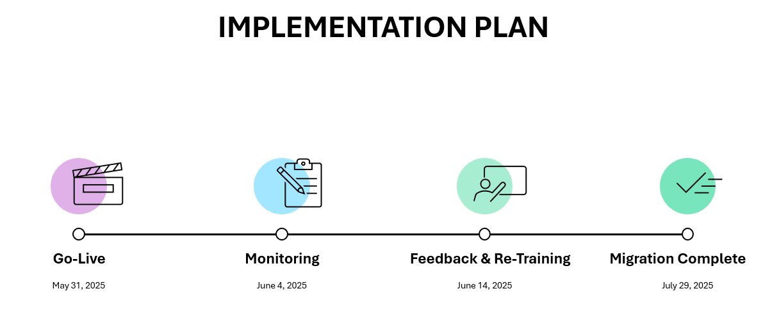

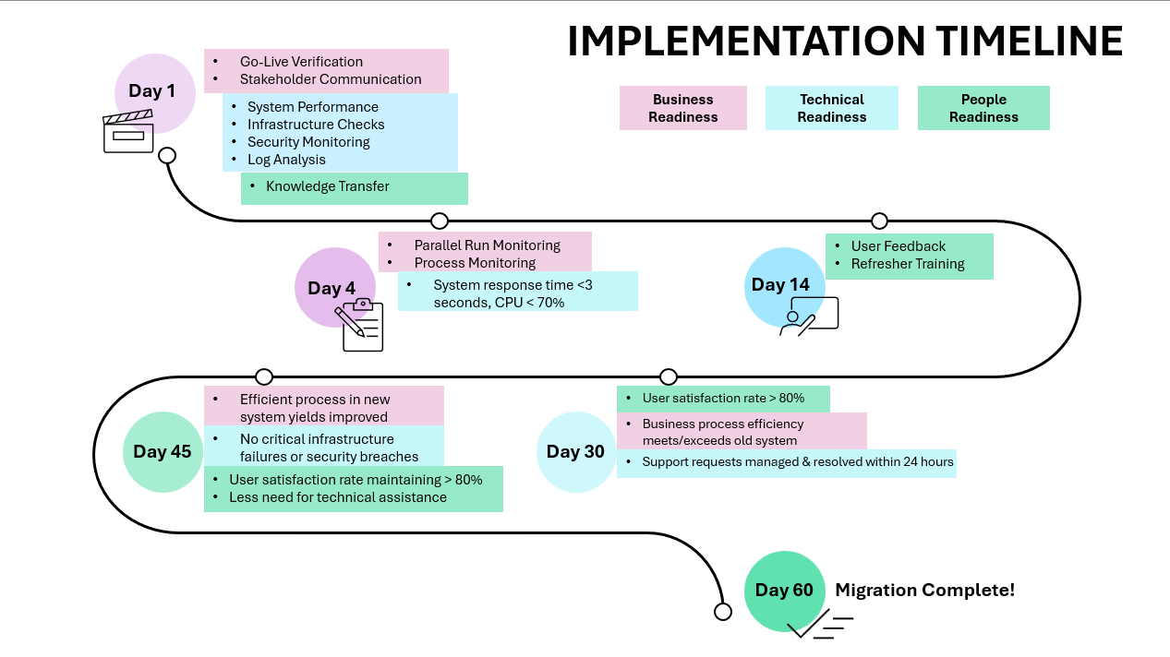

## All Burndown Charts, All Backlogs, All Meeting Logs

**Sprint 1**

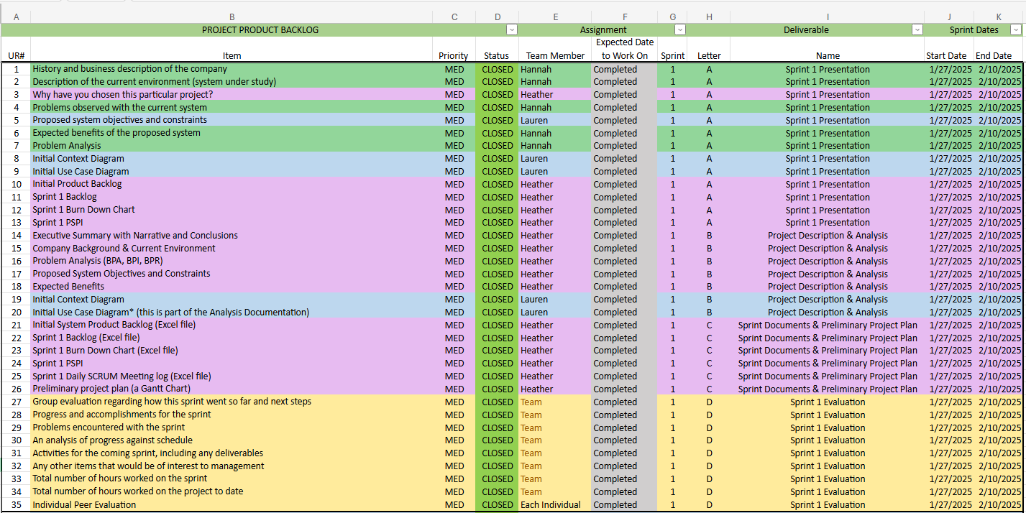

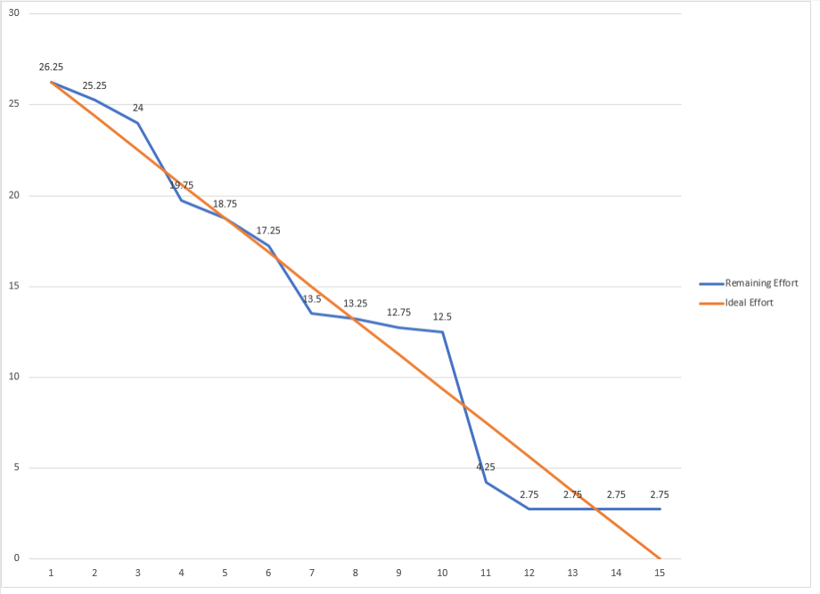

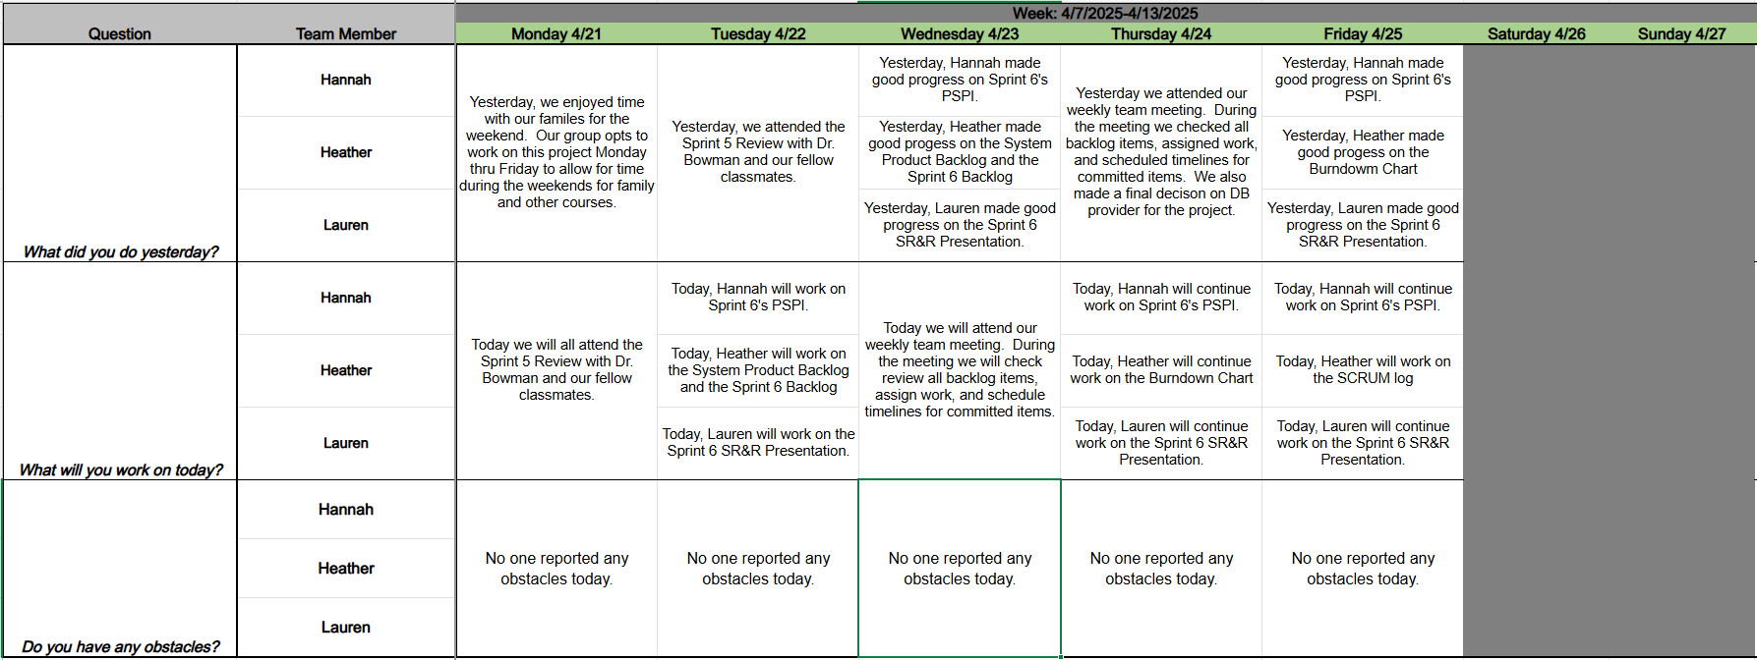

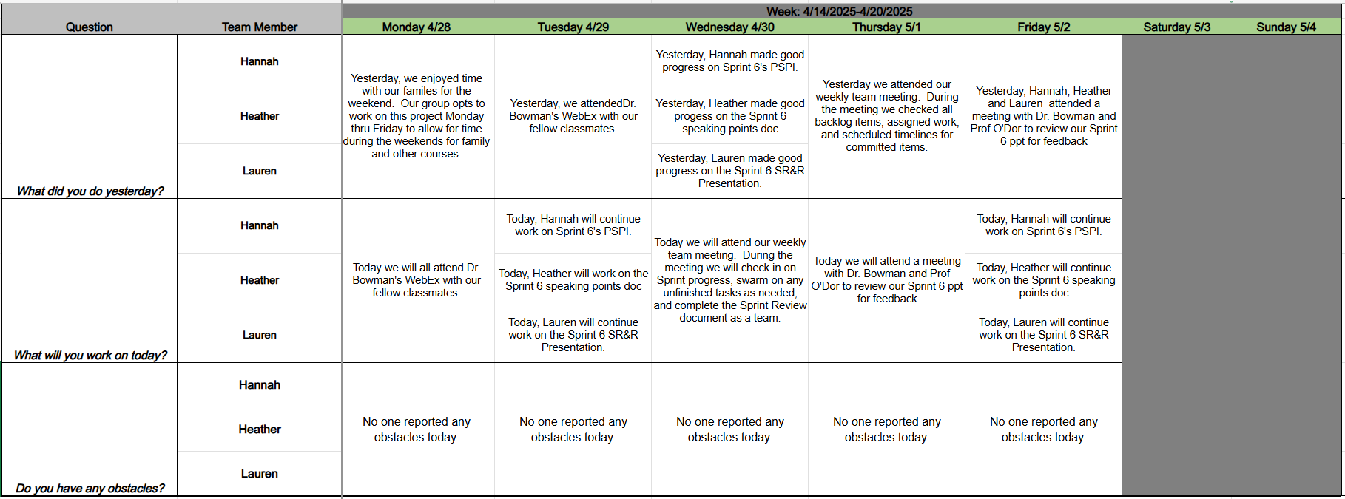

**Sprint 2**

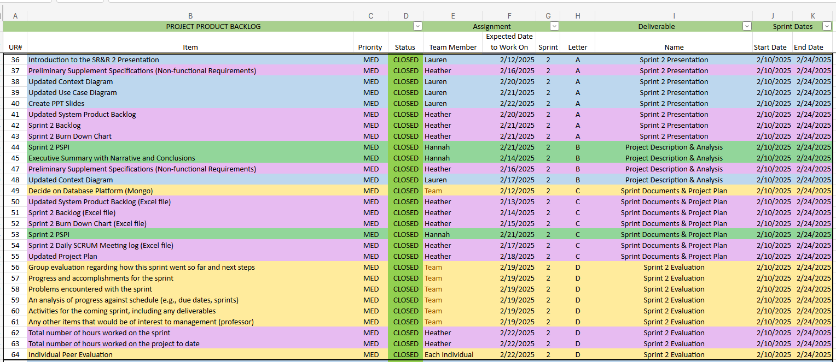

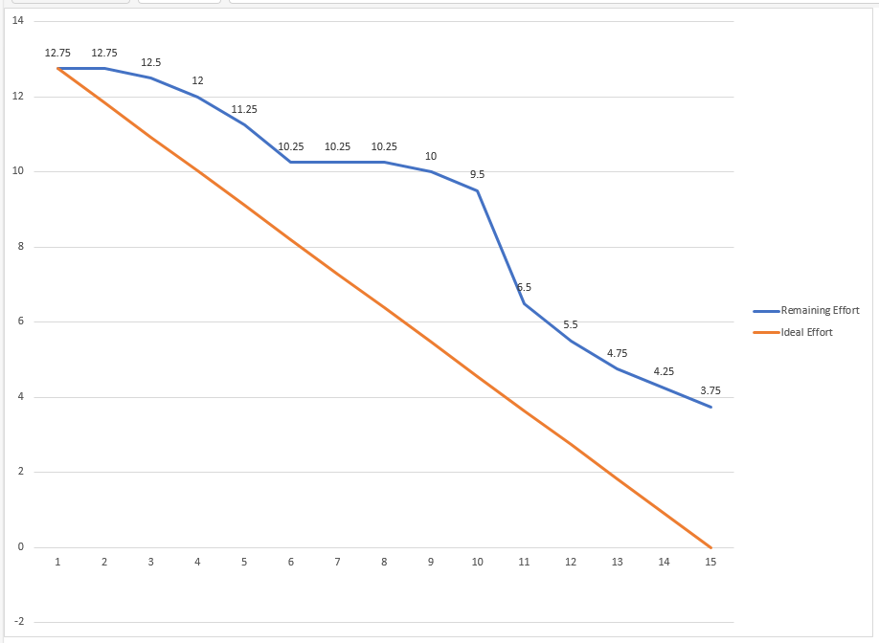

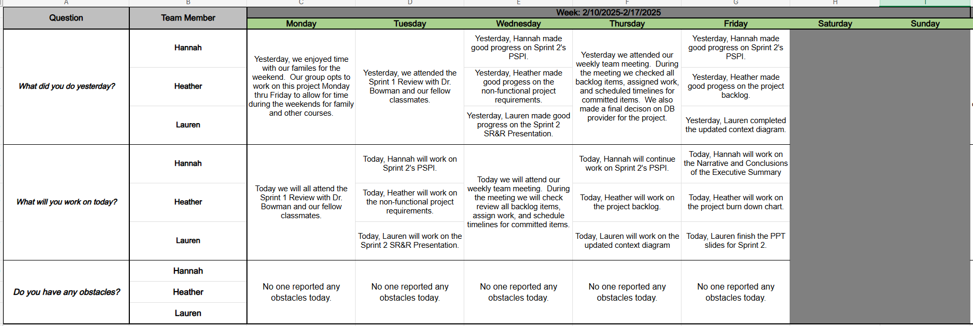

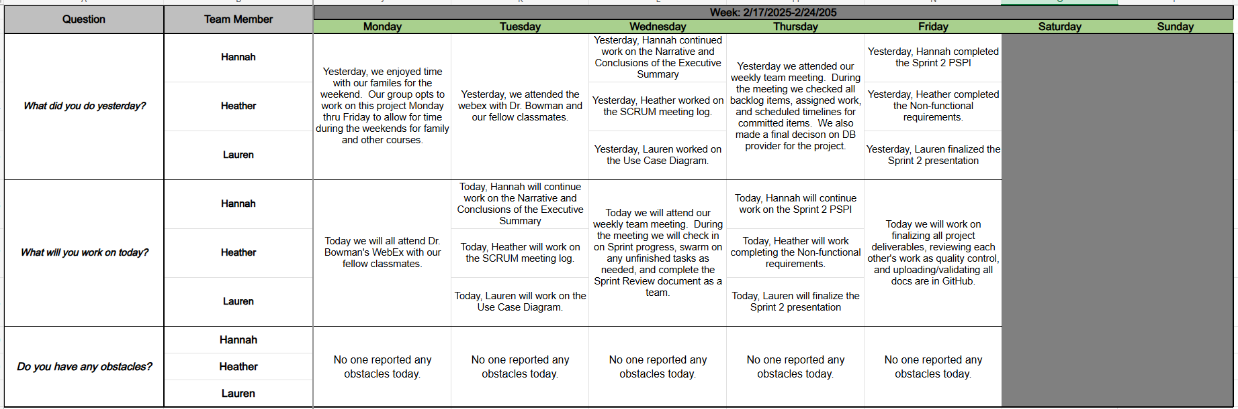

**Sprint 3**

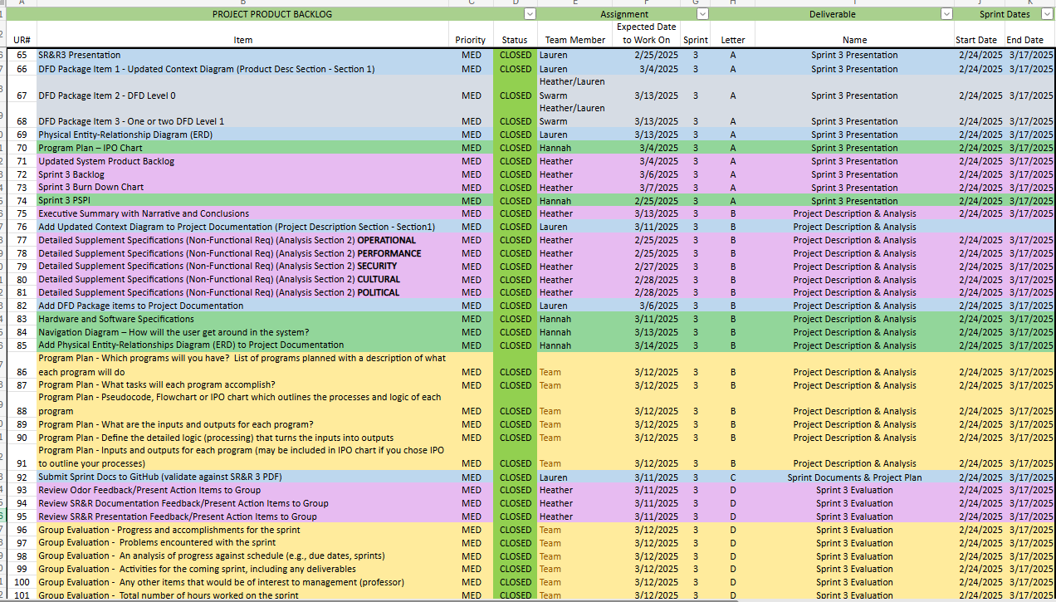

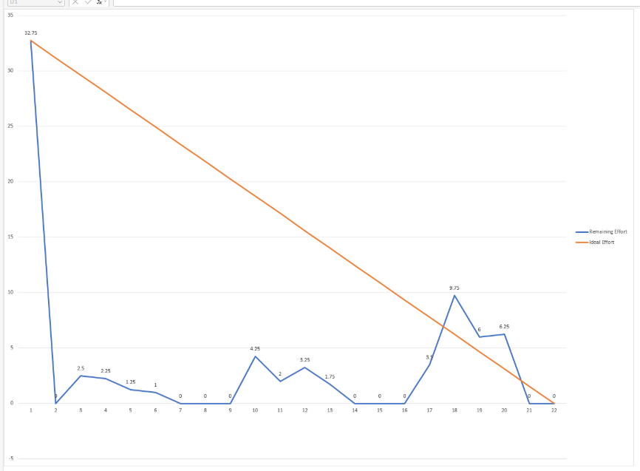

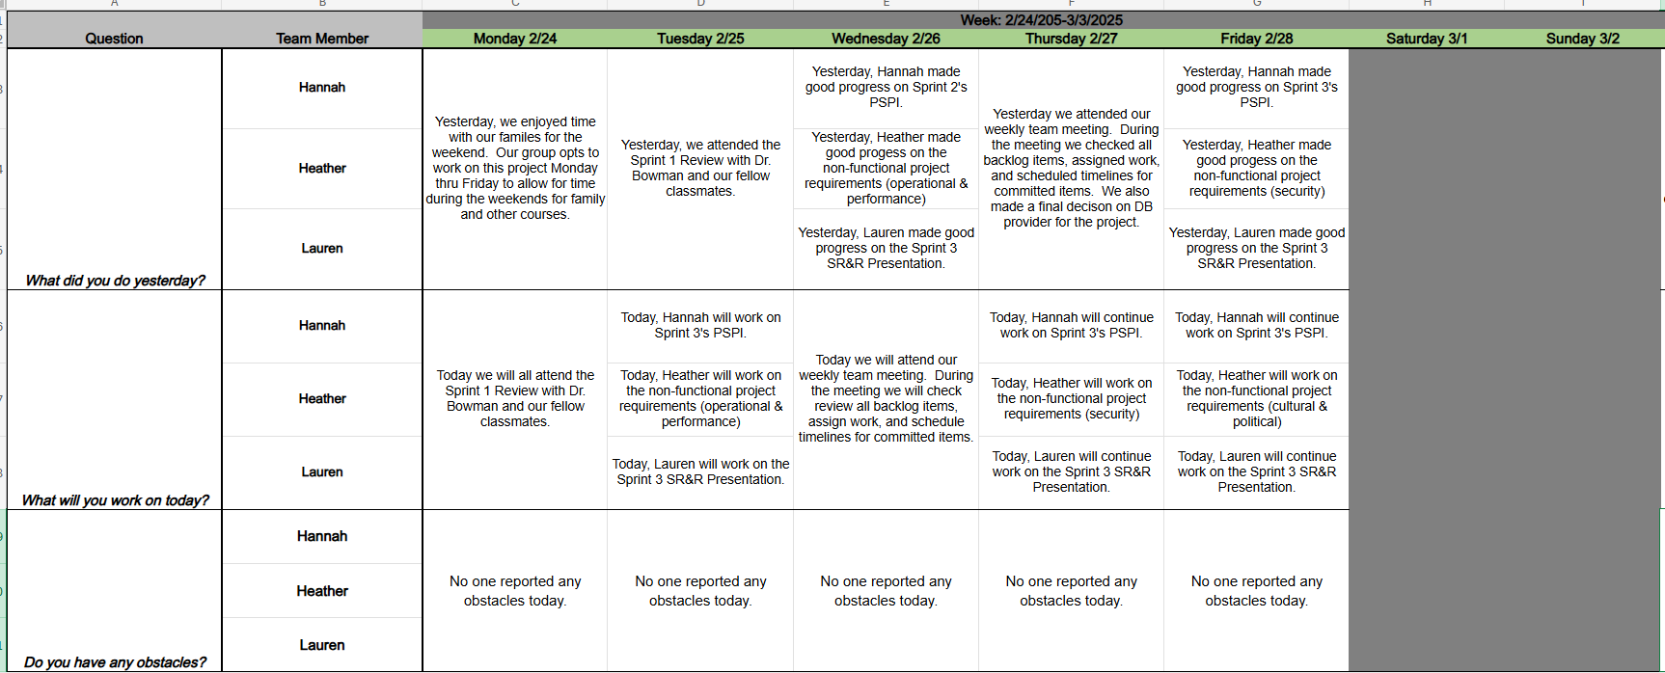

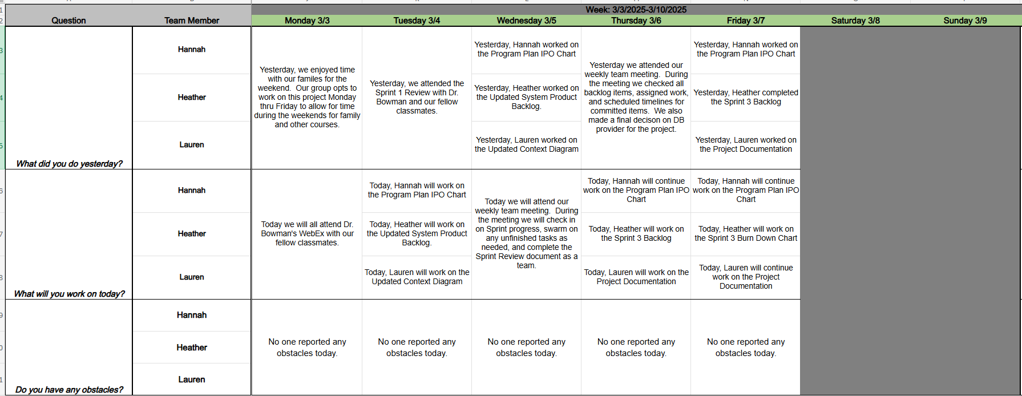

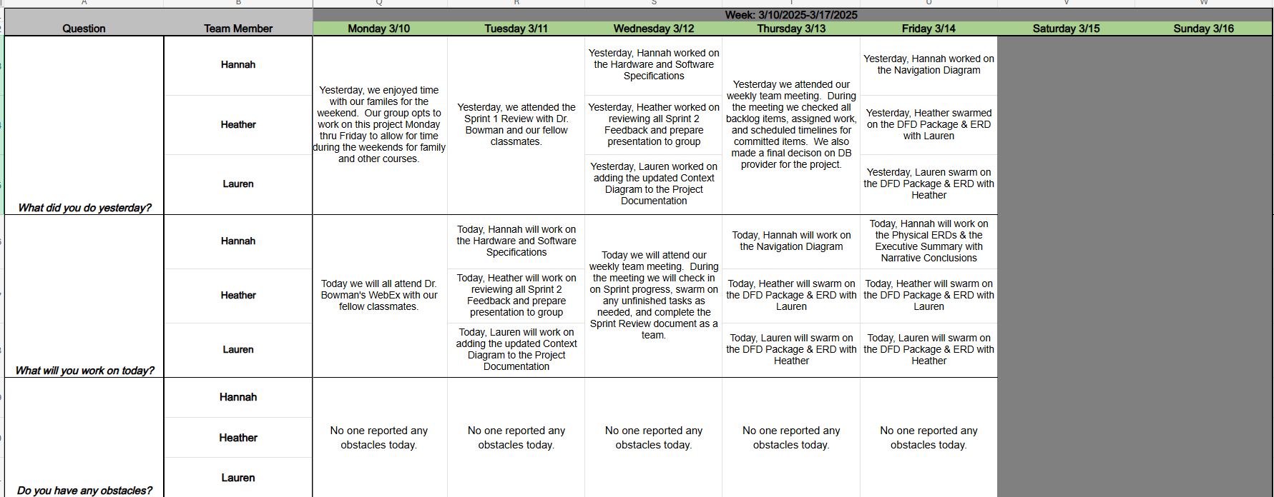

**Sprint 4**

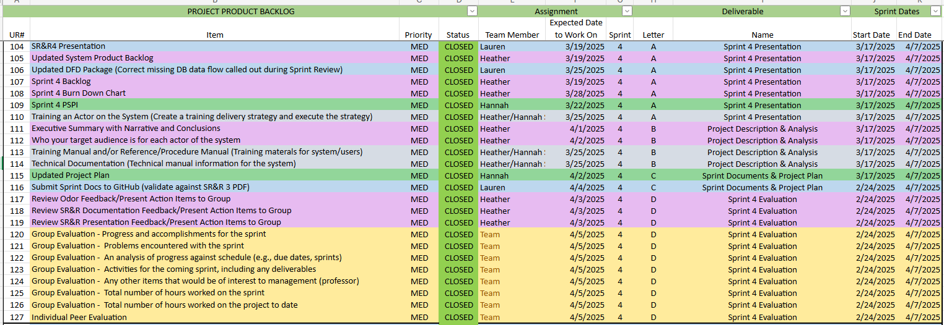

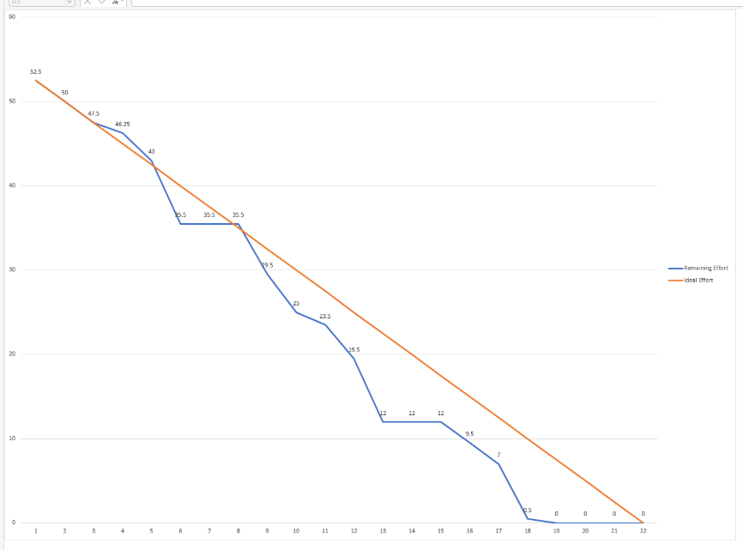

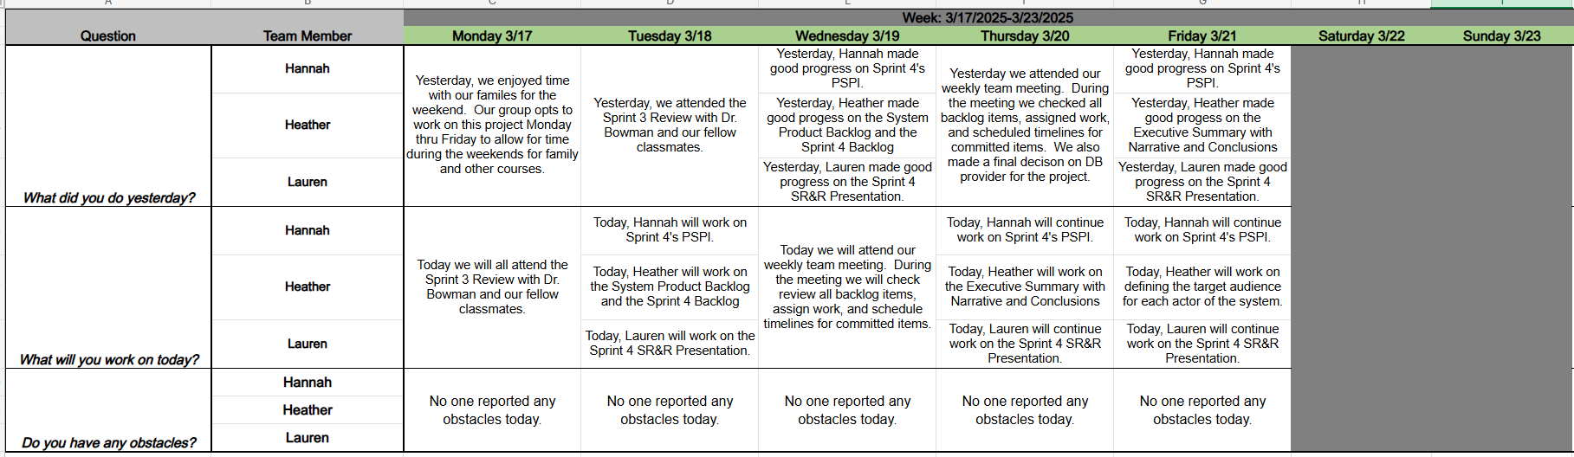

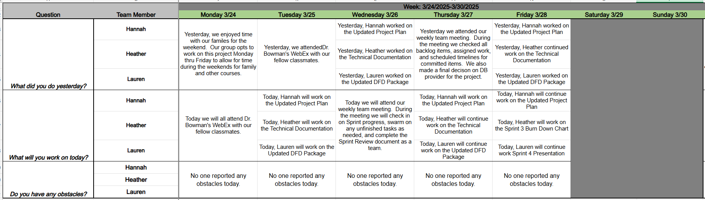

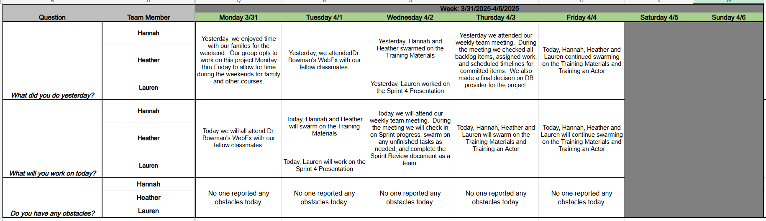

**Sprint 5**

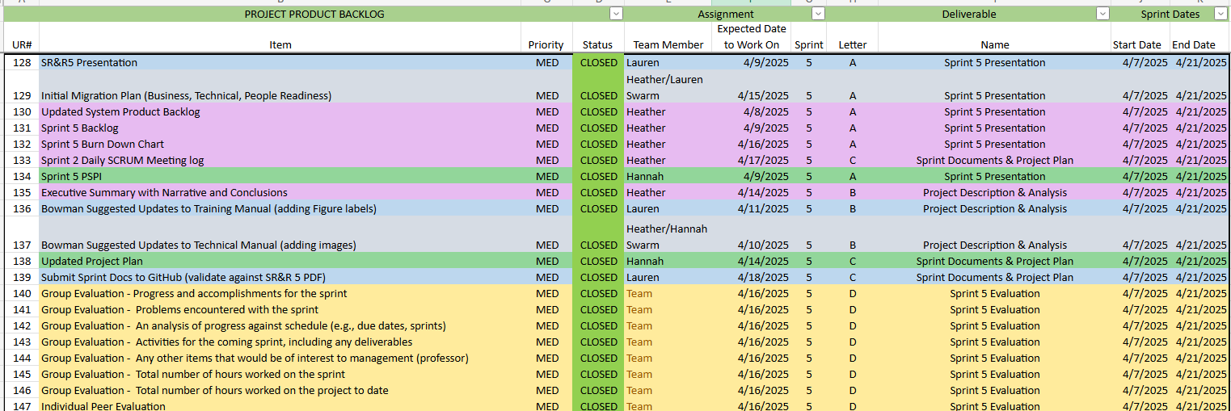

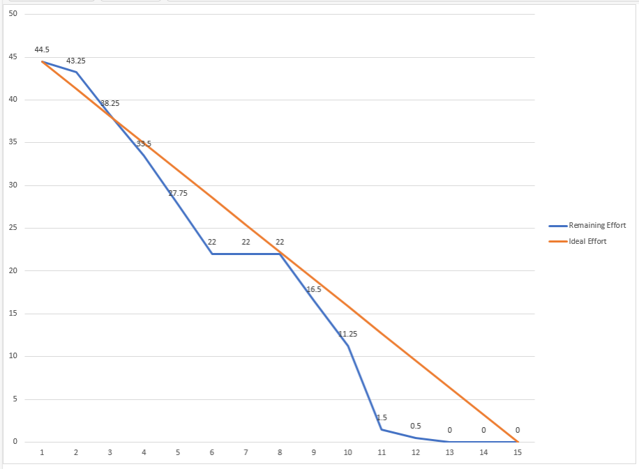

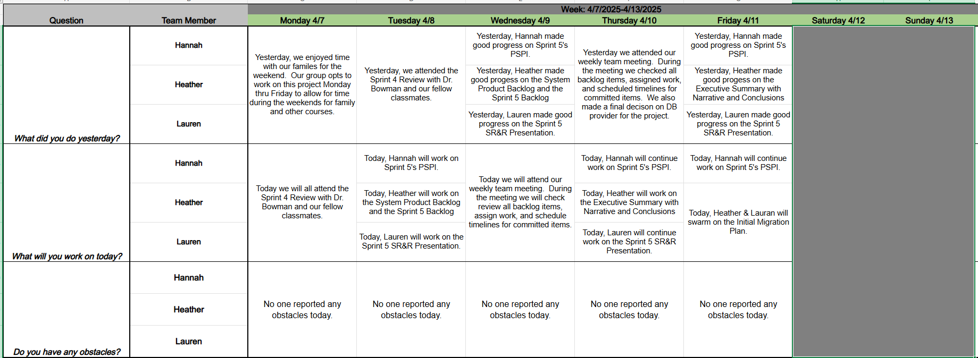

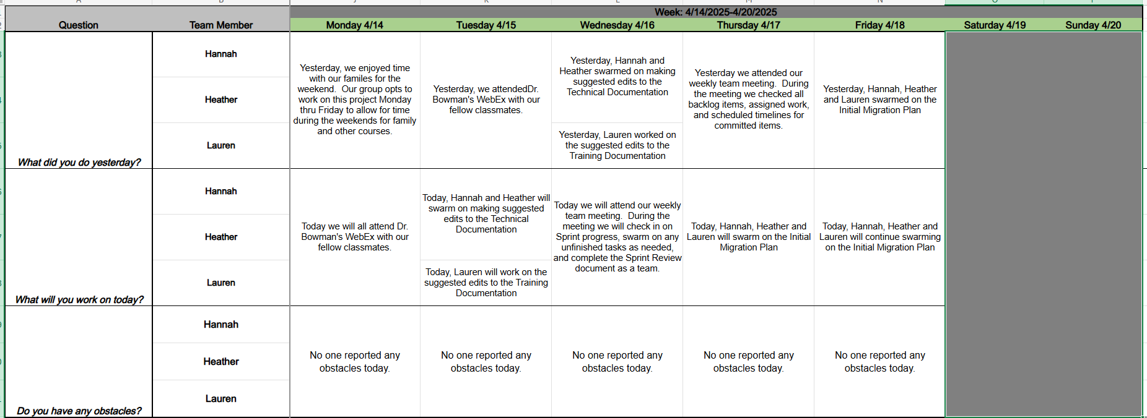

**Sprint 6**

